**User Guide Document**

CareConnect

University of Maryland Global Campus

SWEN 670 - Software Engineering Capstone

Dr. Mir Assadullah

August 3rd, 2025

Contributors: Diane Angeles, Torie Bias, Juan Gaucin Calderon, Luke Curran, Ashenafi Grbreegziabhere, Alyssa Marielle Harding, Astha Malla-Paudel, Maria Ramirez, Edwenson Raphael, Dat Truong, Alex Vecchioni, Christian Yawn

**Revision History**

|  |  |  |  |
| --- | --- | --- | --- |
| **Date** | **Version** | **Description** | **Author** |
| 08/03/2025 | 1.0 | Initial Release | CareConnect Team |
|  |  |  |  |
|  |  |  |  |

**Sign-off Sheet**

|  |  |  |  |
| --- | --- | --- | --- |
| **Role** | **Name** | **Signature** | **Date** |
| Project Manager | Alireza Minagar |  |  |
| Team Lead | Alyssa Harding |  |  |
| Lead Tester | Juan Gaucin |  |  |
| Client | Dr. Mir Assadullah |  |  |

Table of Contents

1. Introduction 6

1.1 Purpose 6

1.2 Intended Audience 6

1.3 Project Documents 6

1.4 Acronyms, Terms, and Definitions 7

2. System Capabilities 7

2.1 Overview 7

2.2 Dataflow 7

3. Technical Specifications and Requirements 7

3.1 Hardware 8

3.2 Software 8

3.3 Network 8

4. User Guide 8

4.1 Onboarding & Authentication 8

4.1.1 Welcome 8

4.1.2 User Registration 8

4.1.3 Login/Logout 9

4.1.4 Password Reset & Account Recovery 9

4.2 Billing & Subscription Management 10

4.2.1 Basic Billing/Payment to User 10

4.2.1 Subscription Activation 10

4.2.3 Subscription Change 11

4.2.4 Subscription Cancellation 12

4.3 User & Role Management 13

4.3.1 User & Role Management 13

4.3.2 Caregiver Profile 14

4.3.3 Patient Profile 17

4.3.4 Multi-Caregiver Support 21

4.3.6 Patient Add Family Member (Email Invite) 28

4.3.7 Family "Read-Only" Access 30

4.4 Dashboards & Menus 31

4.4.1 Patient Dashboard 31

4.4.2 Caregiver Dashboard 34

4.4.3 Patient Action Items Menu 37

4.4.4 Caregiver Action Items Menu 41

4.5 Scheduling & Notifications 44

4.5.1 Pre-Defined Care Templates 44

4.5.2 Custom Task Scheduling 47

4.5.3 Notification Channels 49

4.5.4 Reminder & Alert System 51

4.6 Health & Wellness Tracking 51

4.6.1 Patient Symptom Tracking 51

4.6.2 Meal & Nutrition Tracking 53

4.6.3 Mood & Wellness Tracking 53

4.7 AI Integration 54

4.7.1 AI Mood Detection / Facial Tracking 54

4.7.2 Ask AI (AI Assistant for Healthcare) 56

4.8 Communication & Media 59

4.8.1 In-App Messaging (Text) 59

4.8.2 Voice & Video Calling 63

4.8.3 Emergency SOS Mode 68

4.8.5 Media Uploads (Photos, Documents, Scans) 73

4.9 Device & Third-Party Integrations 79

4.9.1 Wearables 79

4.9.3 Medication Management 83

4.10 Gamification & Engagement 93

4.10.1 Provide Rewards for Completed Tasks 93

4.10.2 Daily Motivation Messages on Dashboard 94

4.10.3 Leaderboard Opt-in 95

4.10.4 Social Networking (Connect with Other Users) 96

4.11 Analytics & Reporting 101

4.11.1 Dashboard Metrics (Adherence Rates, Vital Trends) 101

4.11.2 Report Exports (CSV, PDF) 103

4.11.3 Real-Time vs. Batch Processing 104

5. Security, Data Management and General Settings 105

5.1 AI Configuration 105

5.2 Clear Cache 109

5.3 Switch to Dark Mode and Light Mode 113

6. Troubleshooting 115

6.1 Common Issues and Solutions 115

6.2 Contact Support 115

# 1. Introduction

## 1.1 Purpose

The purpose of this User Guide is to provide comprehensive documentation for users of the CareConnect application. It explains system capabilities, technical specifications, and essential steps to navigate, operate, and troubleshoot the platform.

## 1.2 Intended Audience

This guide is intended for end users of the CareConnect system including patients, caregivers, healthcare professionals, and administrators. It is also useful for IT support staff and developers responsible for maintaining the system.

## 1.3 Project Documents

**Table 1**

*CareConnect Documentation Table*

|  |  |  |
| --- | --- | --- |
| **Document** | **Version** | **Date** |
| Project Plan | 1.0 | 05/31/2025 |
| Software Requirements Specification | 1.0 | 05/31/2025 |
| Technical Design Document | 1.0 | 06/14/2025 |
| Software Test Plan | 1.0 | 06/14/2025 |
| Programmer’s Guide | 1.0 | 07/26/2025 |
| Deployment & Operations Guide | 1.0 | 07/26/2025 |
| User Guide | 1.0 | 08/03/2025 |
| Test Report | 1.0 | 08/03/2025 |

## 1.4 Acronyms, Terms, and Definitions

* **UI** – User Interface
* **AI** – Artificial Intelligence
* **SOS** – Emergency distress signal
* **QR Code** – Quick Response Code used for linking
* **Telehealth** – Remote diagnosis and treatment using telecommunications
* **HIPPA** - Health Insurance Portability and Accountability Act

# 2. System Capabilities

## 2.1 Overview

CareConnect is a mobile and desktop platform designed to coordinate care for patients and caregivers. It offers modules for scheduling, symptom tracking, communication, AI-powered assistance, and third-party device integration. Users can manage appointments, track wellness, interact with care teams, and access personalized health insights.

## 2.2 Dataflow

The CareConnect system architecture is designed using a modular and service-oriented approach. Key components include:

* **Frontend Application:** User interface for patients and caregivers to interact with system features
* **Backend Services:** Handle data processing, storage, user authentication, and notifications
* **Database Layer:** Stores user data, schedules, health records, and media
* **AI Integration:** Connects to third-party APIs and ML models for mood detection, smart scheduling, and symptom analysis
* **Wearables Integration:** Enables the connection of health watches to collect vital signs or health data from patients.
* **Notification Engine:** Triggers alerts, reminders, and real-time messages

Data flows securely between user interfaces, backend logic, and cloud storage with encryption and access control mechanisms in place.

# 3. Technical Specifications and Requirements

CareConnect is built with a set of technology stack that is reliable and popular. It supports a wide range of devices and operating systems. Although we recommend using recent versions of software published at least from the date of CareConnect release.

## 3.1 Hardware

* Smartphones or tablets (Android 10+, iOS 13+)
* Desktop or laptop computer with at least 8GB RAM, 2GHz processor
* Camera and microphone for telehealth features
* Internet-connected wearable devices (optional)

## 3.2 Software

* The family of Android 10+, iOS 13+ for mobile users.
* Chrome 138+, Firefox 141+ or any reliable web browser.

## 3.3 Network

* Broadband internet connection (minimum 10 Mbps)
* HTTPS access for all API endpoints
* Support for secure WebSocket connections (for live chat, video calls, and notifications)

# 4. User Guide

## 4.1 Onboarding & Authentication

### 4.1.1 Welcome

1. Open the CareConnect app on your mobile device or visit the web portal.

2. Review the welcome screen to understand the platform’s key features.

3. Tap 'Next' or 'Get Started' to proceed to registration or login.

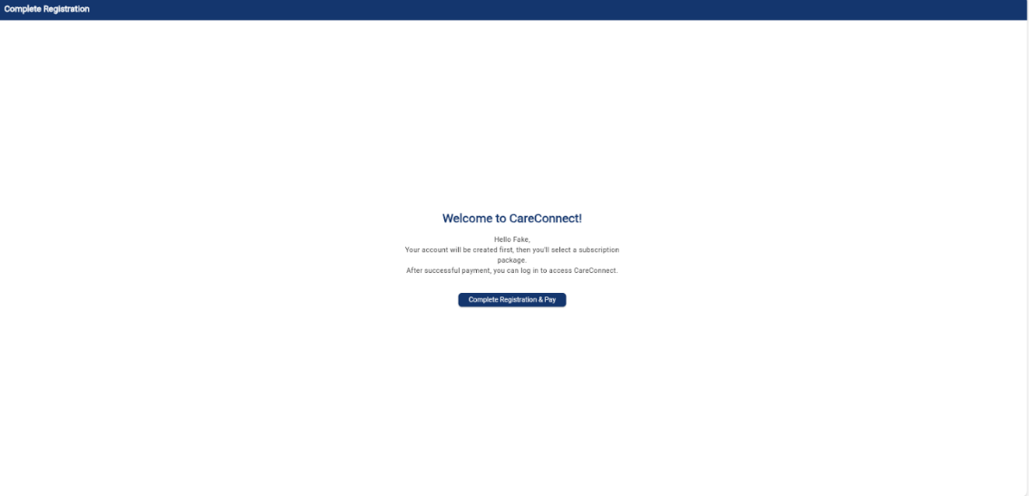

### 4.1.2 User Registration

1. Tap on 'Sign Up' from the welcome screen.

2. Choose your role: Patient or Caregiver.

3. Enter your full name, email address, and create a secure password.

4. Agree to the Terms of Service and tap 'Register'.

5. Check your email for a verification link and tap it to complete setup.

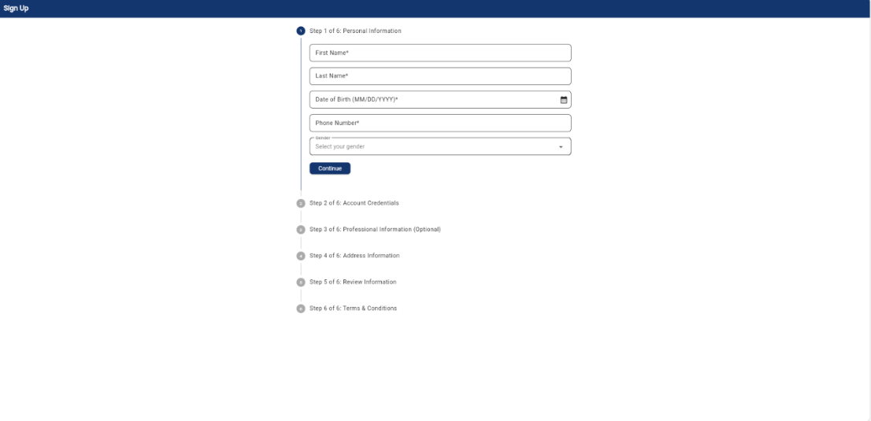

### 4.1.3 Login/Logout

1. Open the app and tap 'Login'.

2. Enter your registered email and password.

3. Tap 'Login' to access your dashboard.

4. To logout, tap your profile icon and select 'Logout'.

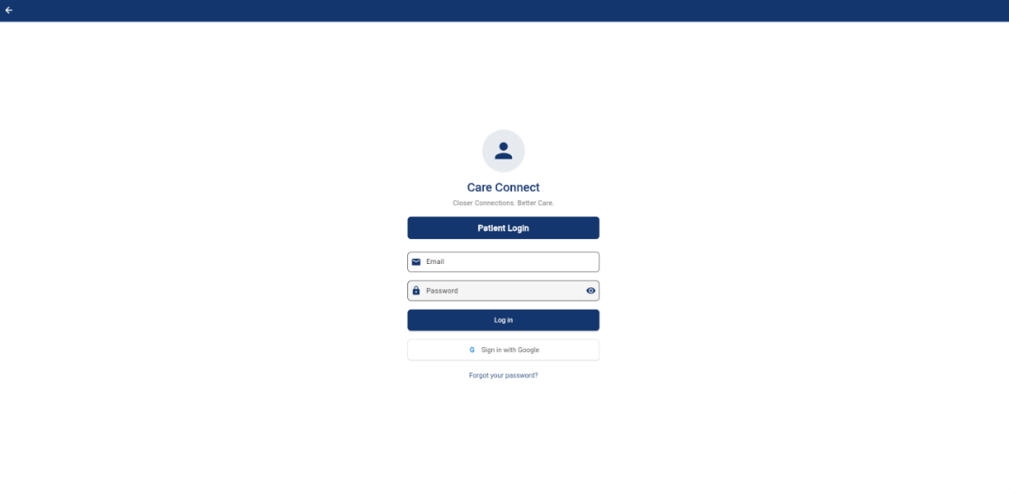

### 4.1.4 Password Reset & Account Recovery

1. On the login screen, tap 'Forgot Password?'.

2. Enter your registered email address and tap 'Send Reset Link'.

3. Open the email and click the reset link.

4. Create a new password and confirm.

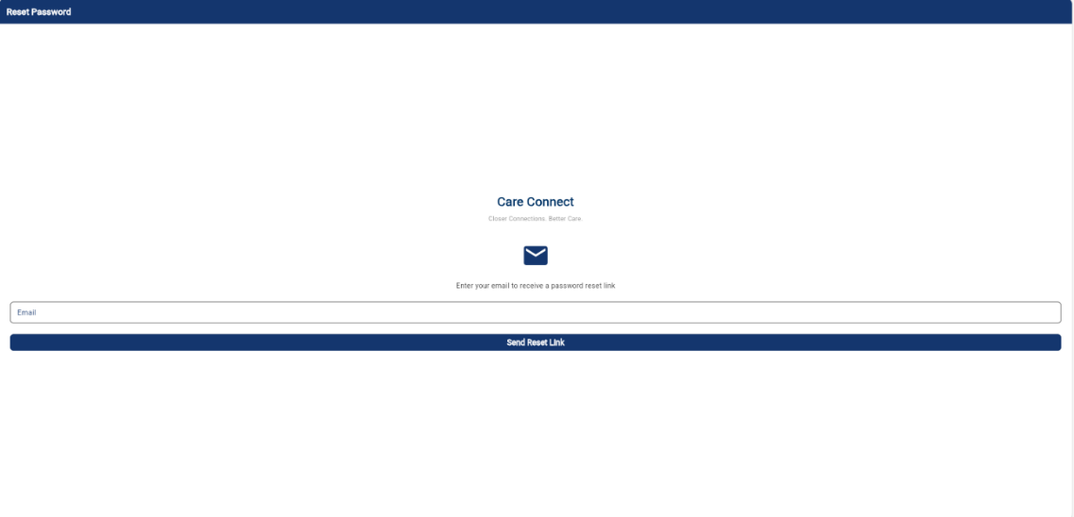

## 4.2 Billing & Subscription Management

### 4.2.1 Basic Billing/Payment to User

1. From your dashboard, tap 'Settings' > 'Billing'.

2. View your current subscription plan and payment history.

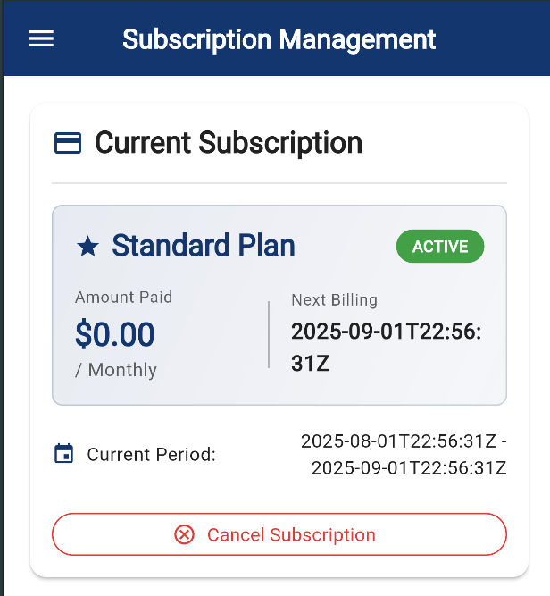

### 4.2.1 Subscription Activation

1. From your dashboard, tap 'Settings' > 'Billing'.

2. Choose a subscription plan

3. Select ‘Pay with Stripe’

4. Fill in details to activate subscription

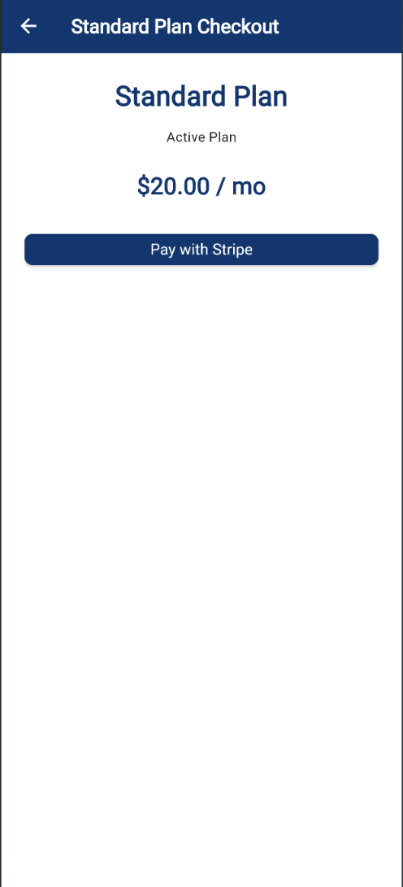

### 4.2.3 Subscription Change

1. From your dashboard, tap 'Settings' > 'Billing'.

2. Select a subscription plan and to switch to.

3. Tap 'Confirm Change' to activate your subscription.

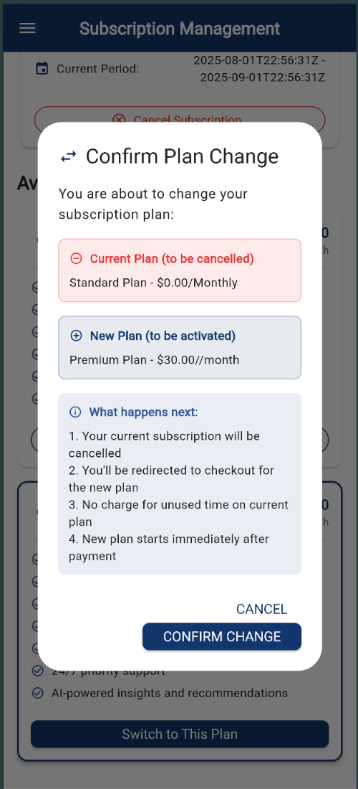

### 4.2.4 Subscription Cancellation

1. From your dashboard, tap 'Settings' > 'Billing'.

2. Select ‘Cancel Subscription’ under current subscription

3. Tap 'Yes, Cancel' to cancel your subscription.

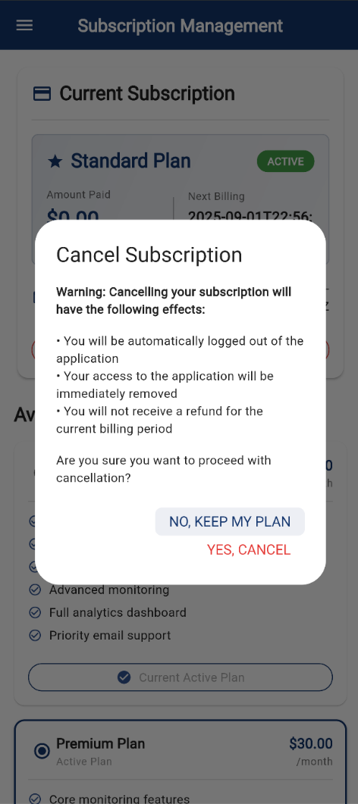

## 4.3 User & Role Management

This section of the User Guide describes how the application handles the user’s manipulations; how to update profile, how do they link with other users and other access controls.

### 4.3.1 User & Role Management

1. Caregivers may remove relationship from caregiver.

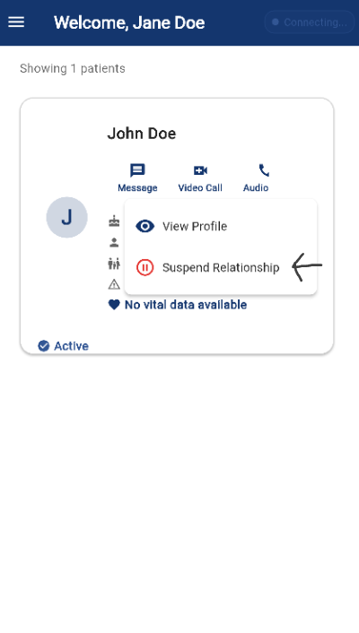

### 4.3.2 Caregiver Profile

1. Open the left sidebar (drawer) using the hamburger button on the top left.

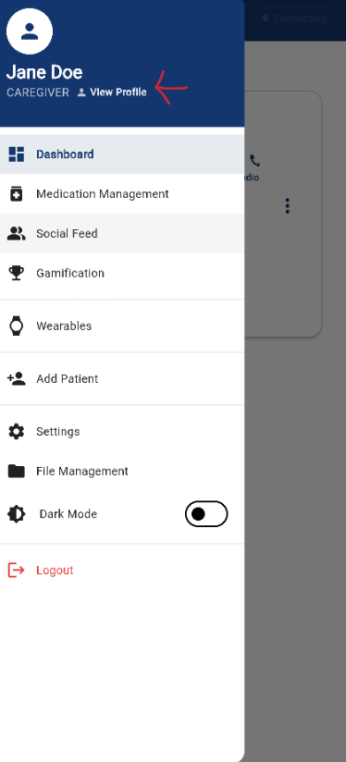

2. Edit your caregiver details: certifications, availability, etc.

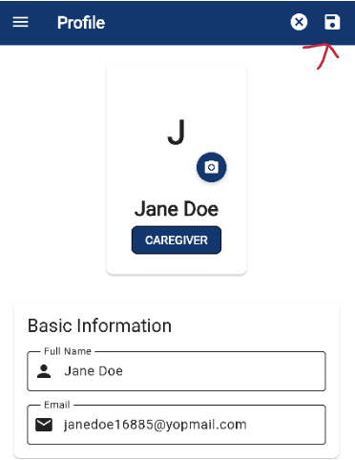

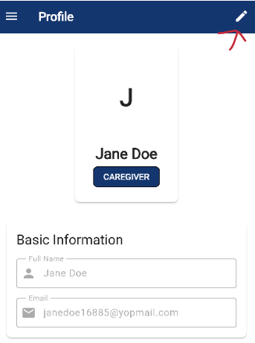

3. Tap 'Save' to apply updates.

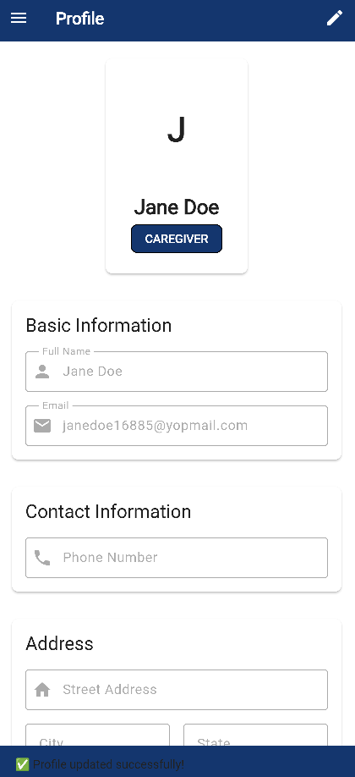

### 4.3.3 Patient Profile

1. Open the left sidebar (drawer) using the hamburger button on the top left.

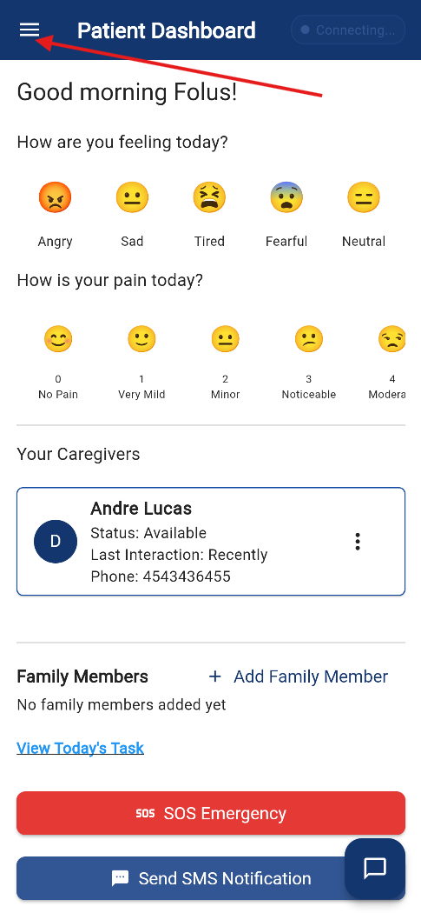

2. Tap/click 'View Profile' to update personal and medical information.

3. Tap/Click on the pencil button icon on the top right to update.

4. Once you are done; Click Save button with the disk icon to update or cross icon button to cancel process.

- On Save you will see a confirmation bar at the bottom of the screen.

### 4.3.4 Multi-Caregiver Support

1. Go the Caregiver Dashboard, Tap/Click on Add Patient

- When there is no patient associated with that caregiver at all.

* Where there is at least one patient already associated with the caregiver, go to the Hamburger menu and click on “Add Patient”

2. Add the patient’s email in the form, Tap/Click on the loop icon to search.

3. When the patient is found, you can fill out the rest of the form and send a connection request.

3.a You will see a confirmation message of the request.

### 4.3.6 Patient Add Family Member (Email Invite)

1. Patients can go to 'Family Access' and tap 'Invite Family'.

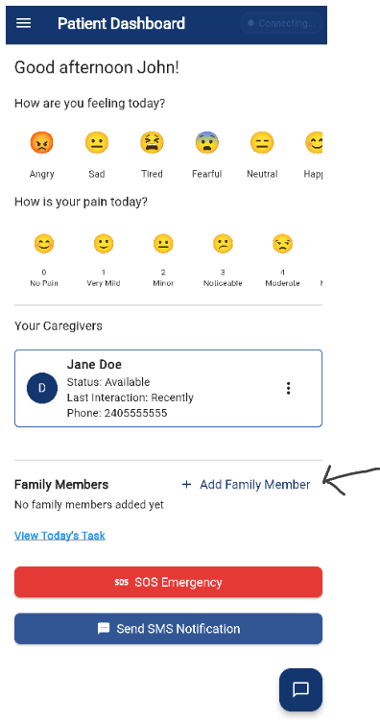

2. Enter the family member’s email and send the invitation.

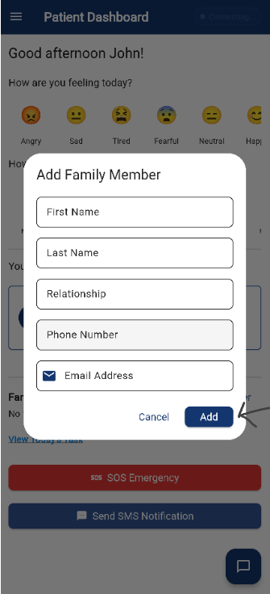

### 4.3.7 Family "Read-Only" Access

1. Family members receive a link to view the patient dashboard.

2. They can monitor progress but cannot make changes

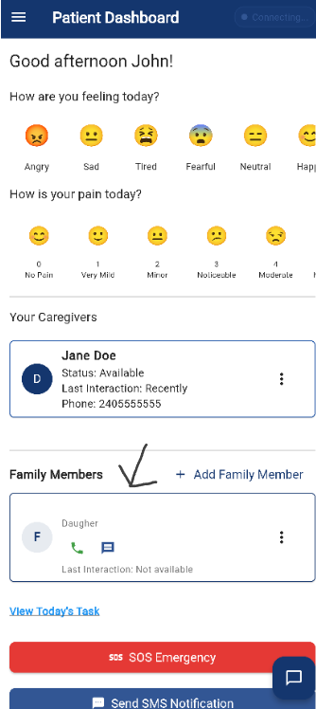

## 4.4 Dashboards & Menus

### 4.4.1 Patient Dashboard

1. Log in as a patient.

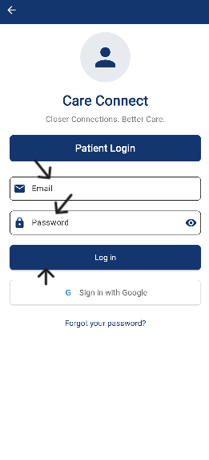

2. On the home screen, review your health summary, daily tasks, and alerts.

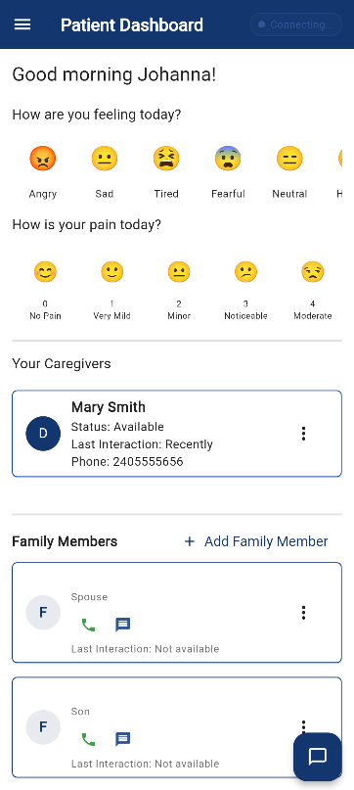

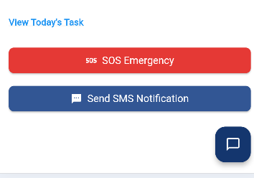

3. Tap on any widget (e.g., medication, vitals) to explore more details.

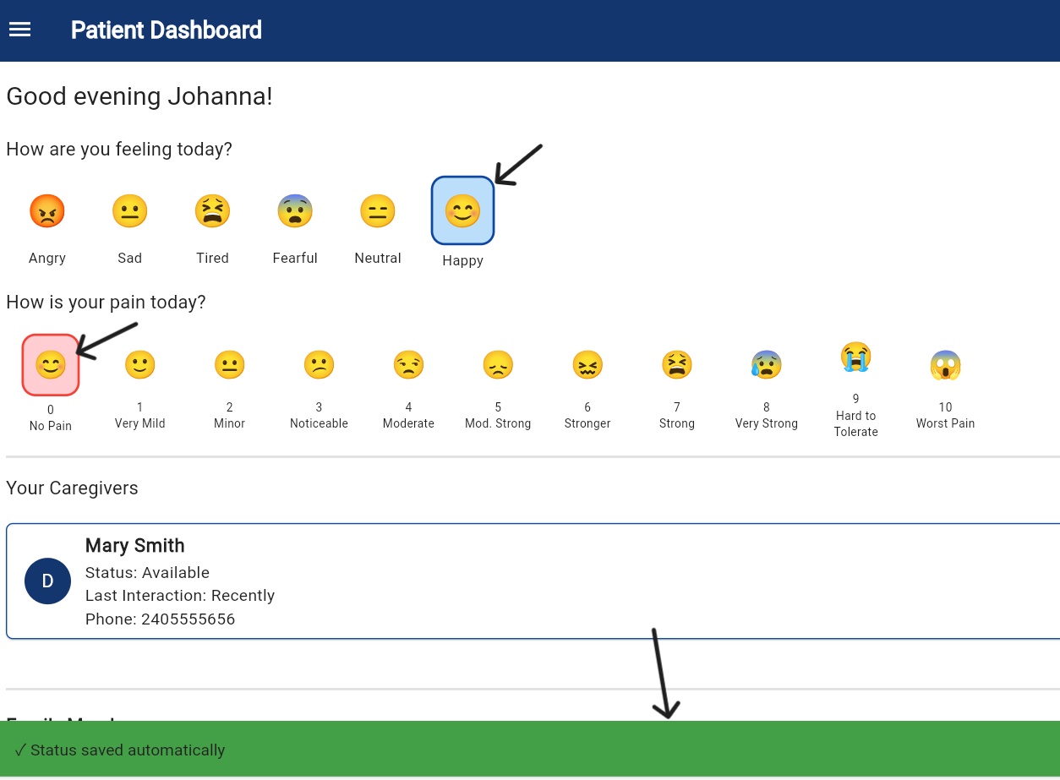

### 4.4.2 Caregiver Dashboard

1. Log in as a caregiver.

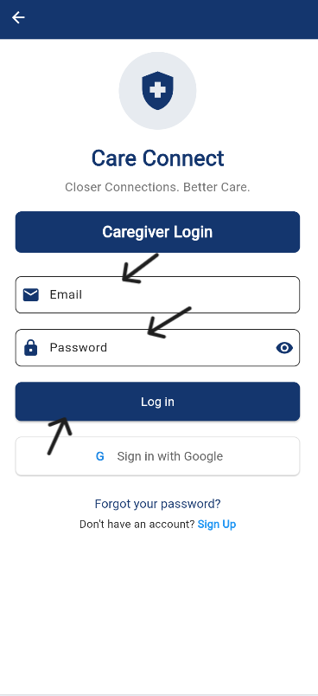

2. Once logged in, the dashboard displays a list of all assigned patients.

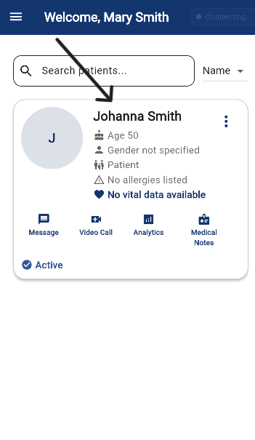

3. Tap a patient’s name to view their recent activities and health updates.

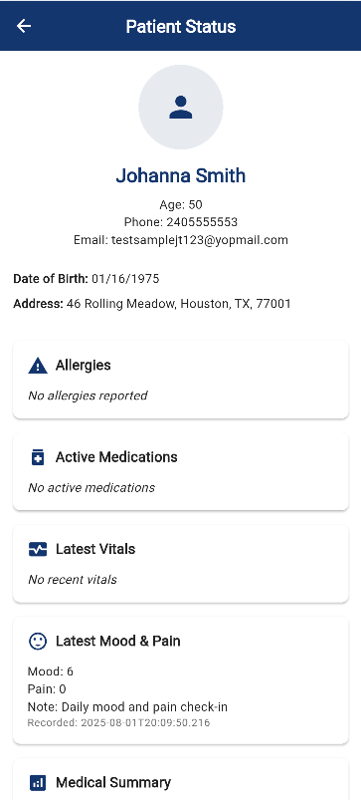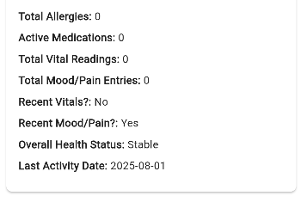

### 4.4.3 Patient Action Items Menu

1. From the dashboard, tap the kebab menu (three dots).

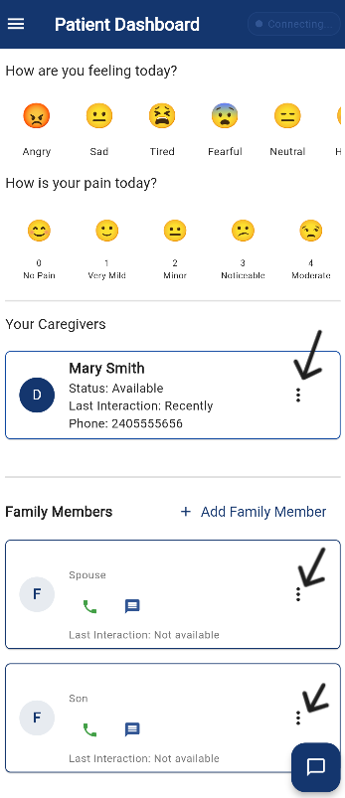

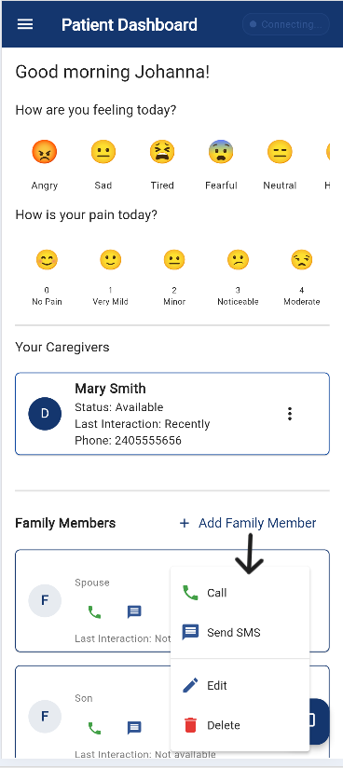

2. Click on the desired action items: (eg. Call, Video call, Email, Send SMS, Edit, Delete)

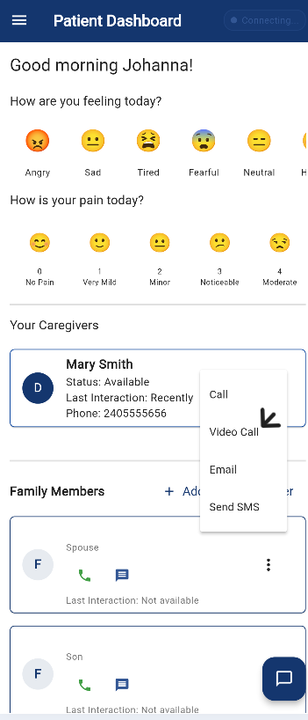

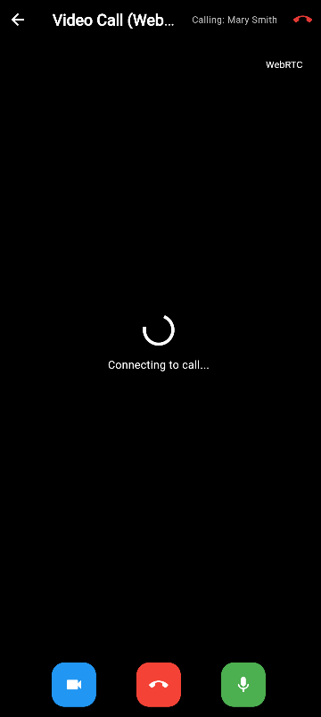

### 4.4.4 Caregiver Action Items Menu

1. From the dashboard, tap the desired action.

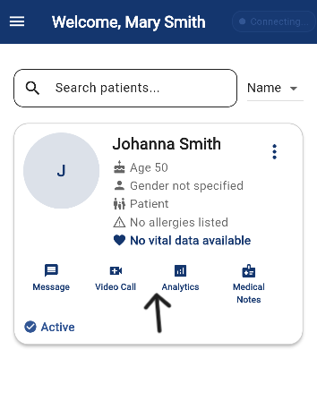

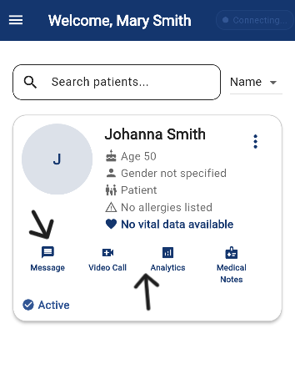

2. Click on the desired action items: (eg. **Message**, Video call, etc.)

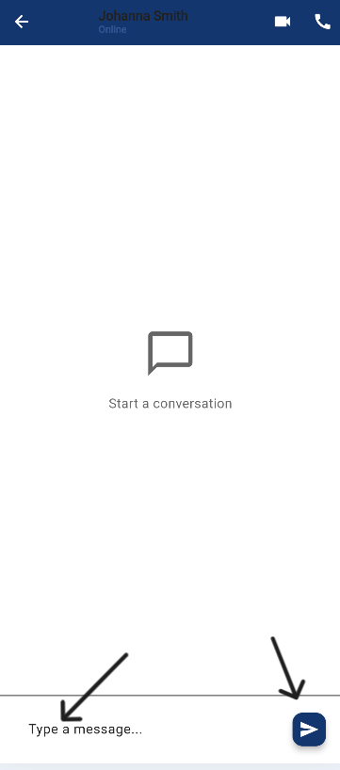

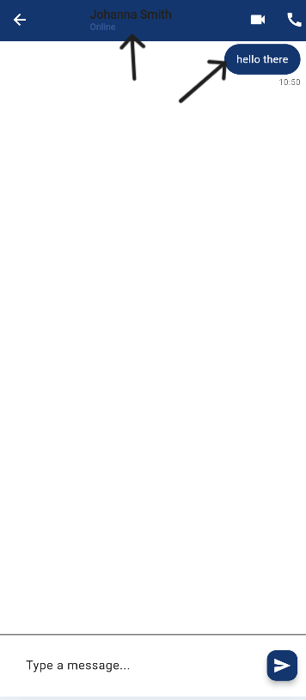

## 4.5 Scheduling & Notifications

### 4.5.1 Pre-Defined Care Templates

1. Tap '+' under the patient's task menu.

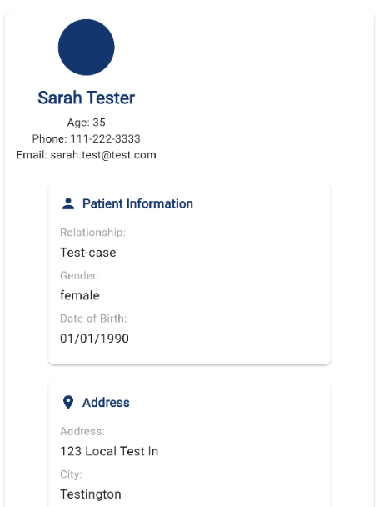 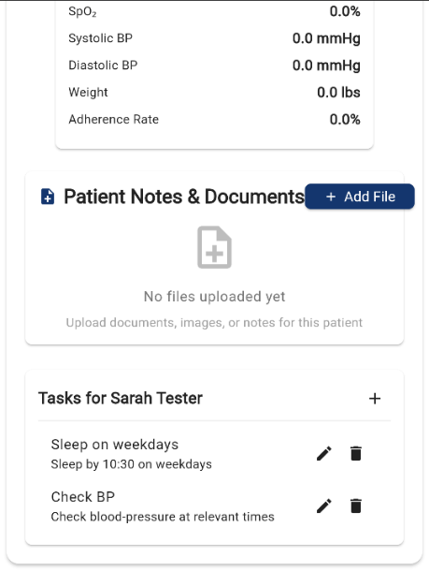

2. Select a condition-based template (e.g., Medication, Meals).

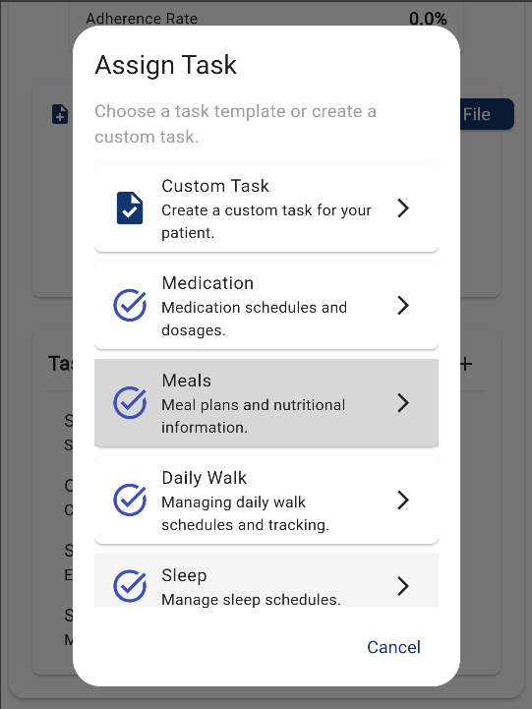

3. Make any desired changes to cater the template to the patient.

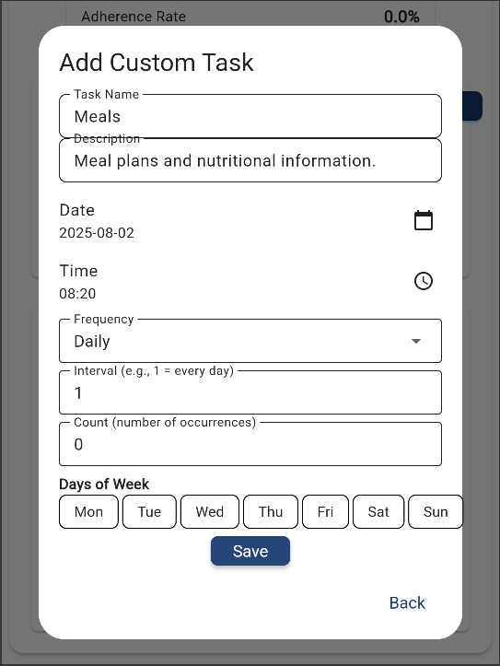

4. Apply to a patient to auto-populate standard tasks.

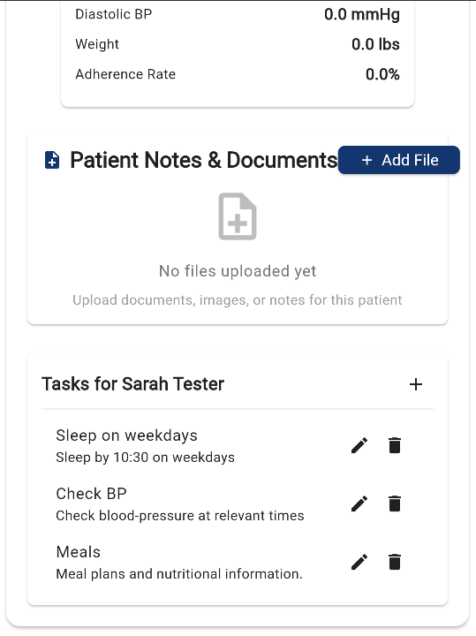

### 4.5.2 Custom Task Scheduling

1. Tap '+' under the patient's task menu.

 

2. Select ‘Custom Task’ from the Assign Task menu.

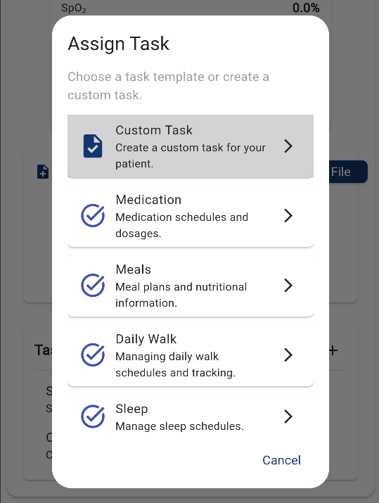

3. Define: task name, description/ instructions, start date, and optionally: time, frequency, interval, number of occurrences, or days of the week to occur on.

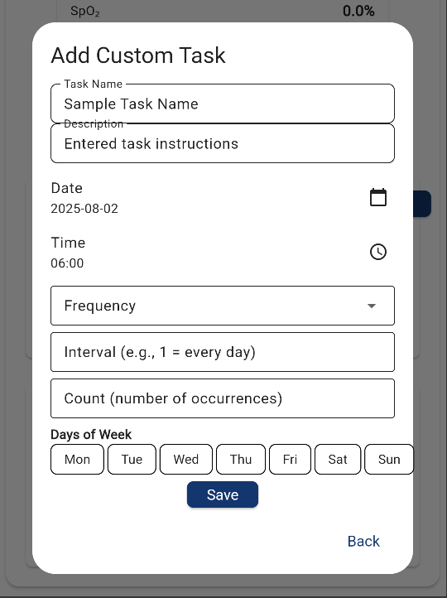

4. Tap 'Save' to add it to the schedule.

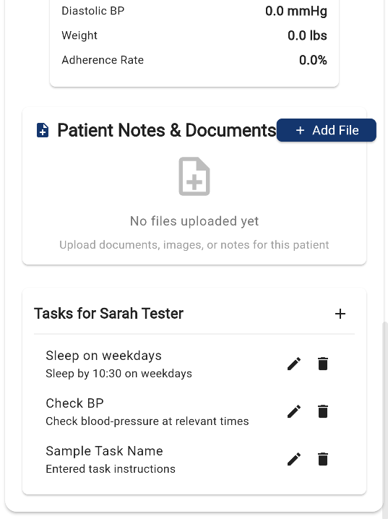

5. Tap the new task to view its details.

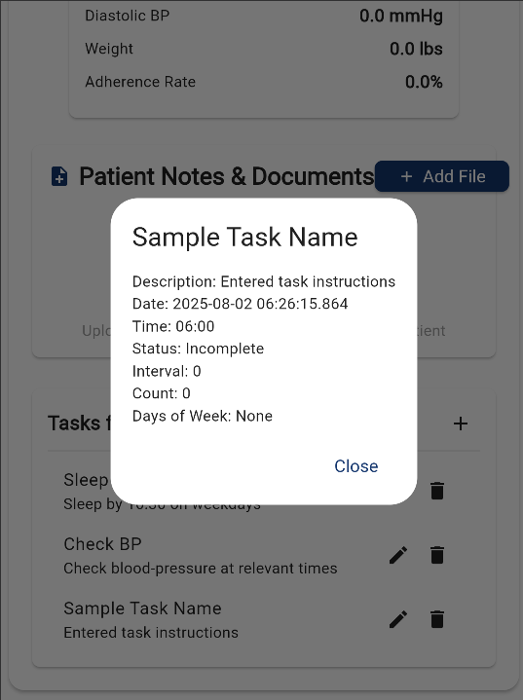

### 4.5.3 Notification Channels

1. Go to 'Settings' > 'Notifications'.

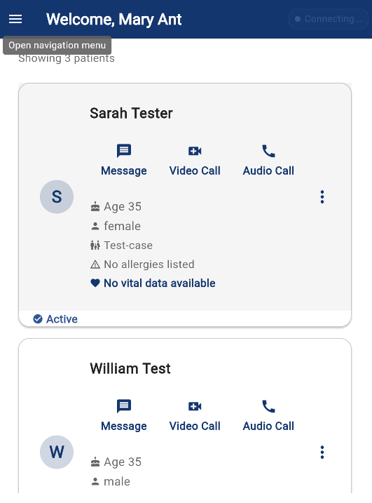

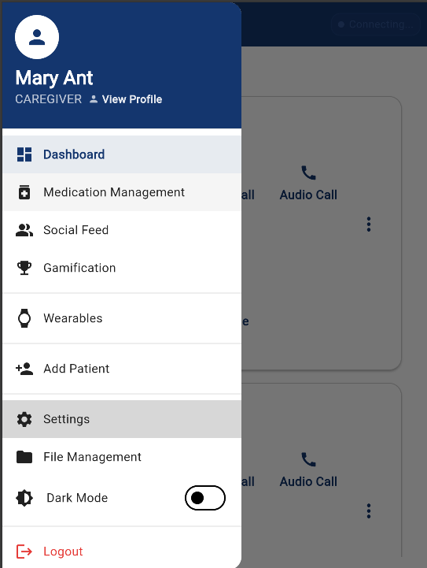

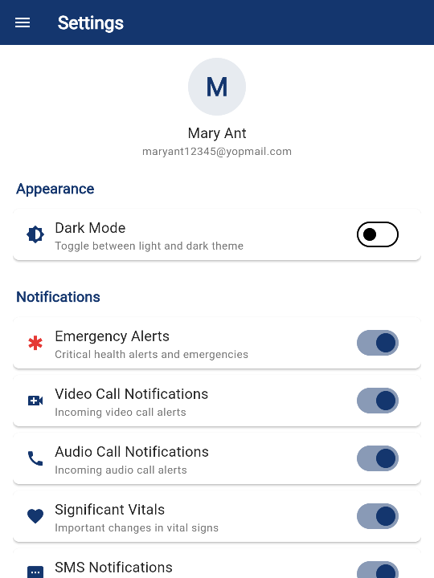

2. Choose your preferred channels: push, SMS, or email.

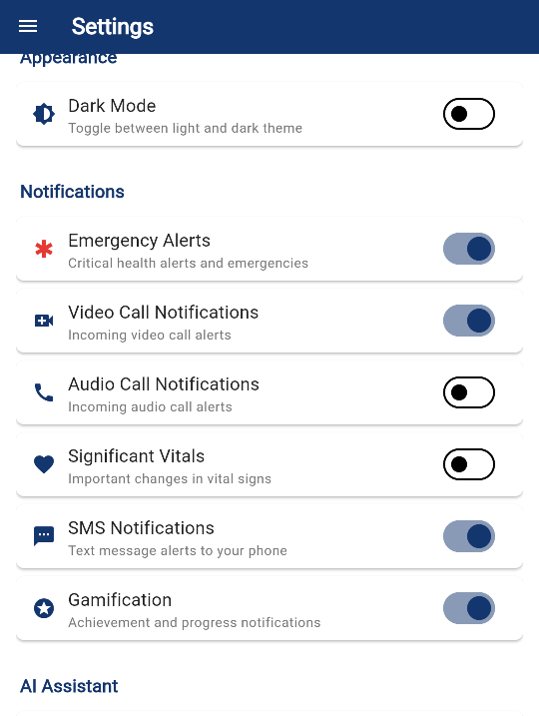

### 4.5.4 Reminder & Alert System

1. Ensure notifications are enabled in app and device settings.

2. Alerts will appear automatically before each scheduled task.

3. Mark tasks as done to dismiss alerts.

## 4.6 Health & Wellness Tracking

### 4.6.1 Patient Symptom Tracking

On the Patient side:

* Once logged in as a Patient, you will see the section labeled "How are you feeling today?".
* Under this section, you will find Emojis representing different emotions. Tap on the emoji that best represents how you are feeling at the moment.
* Below, there is another section titled "How is your pain today?".
* To select your pain level:
  + Scroll over the emojis to view different facial expressions.
  + Each emoji is linked to a pain rating from 1 to 10, with 1 being no pain and 10 being the worst pain possible.
  + Tap the emoji that corresponds to your pain level.

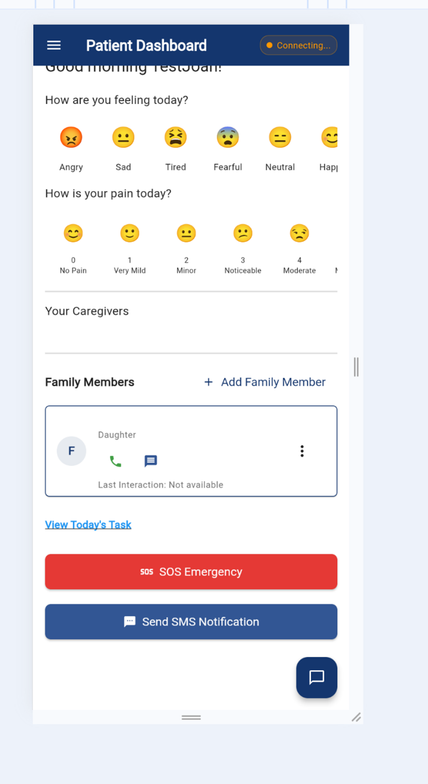

On the Caregiver Side:

* Once logged in, on the Patient’s card, look for the Vital Data link located next to the heart symbol.
* If data is available, it will show "Vital Data Available".
* If there is no data available, it will display "No Vital Data Available".

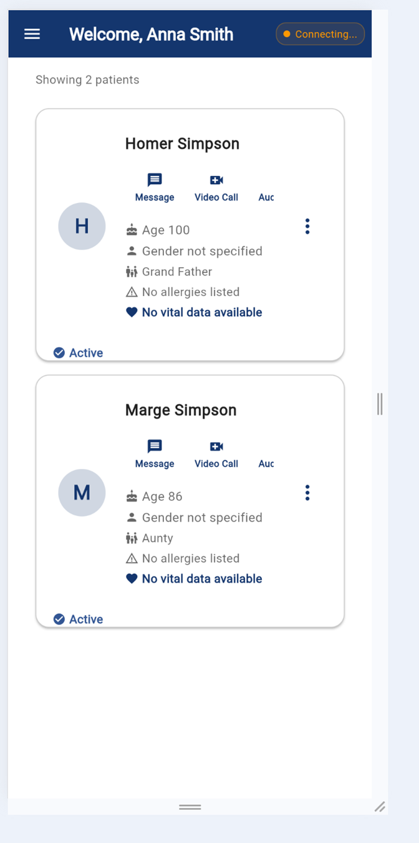

### 4.6.2 Meal & Nutrition Tracking

1. Tap 'Meal Log' in the Health section.

2. Enter meal type, time, ingredients, and portion.

3. Save to maintain daily nutrition logs.

### 4.6.3 Mood & Wellness Tracking

1. Tap 'Mood Tracker' from the Wellness menu.

2. Choose your current mood from emojis or slider.

3. Optionally add comments and submit.

## 4.7 AI Integration

### 4.7.1 AI Mood Detection / Facial Tracking

1. Ensure camera permissions are enabled for the app
2. On the selected Patient/Caregiver card, there is a video call symbol. The text next to the symbol will say “Video Call”. Click on it to start the video call.
3. After tapping, a screen will appear that says, “Start Call”. Tap on it to initiate the call.
4. Microphone permissions will be requested. Choose your desired option to allow the microphone.
5. During the call, a Facial Mood Detection feature will be displayed on the left side of the screen.
6. This feature uses emojis to depict the facial emotions of the caller, based on their expressions.
7. The mood of the caller is detected in real-time and will be updated as the call progresses.

Caregiver Side: When Caregiver is logged in.

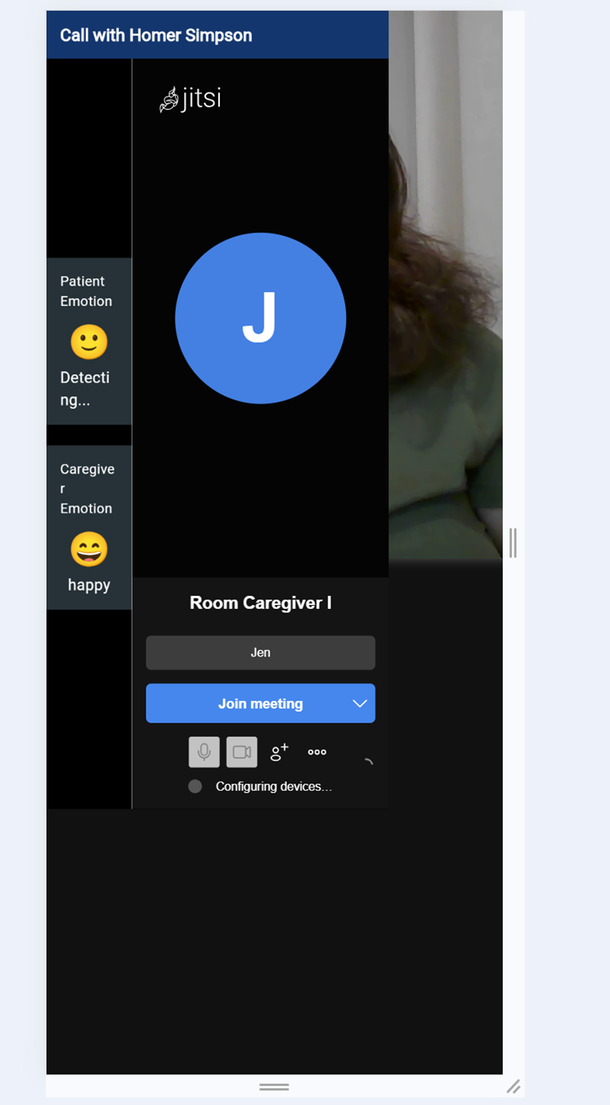

Patient side: When Patient is logged in:

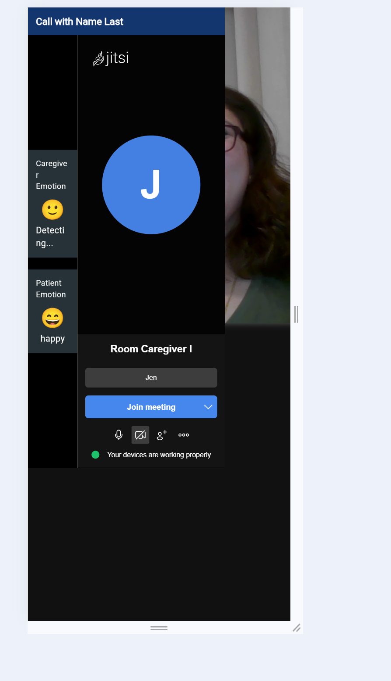

### 4.7.2 Ask AI (AI Assistant for Healthcare)

1. The Ask AI feature is available for the Patient (Care Receiver).
2. To access it, locate the blue chat button on the bottom-right corner of the page. Tap on it to open the Health Assistant interface.

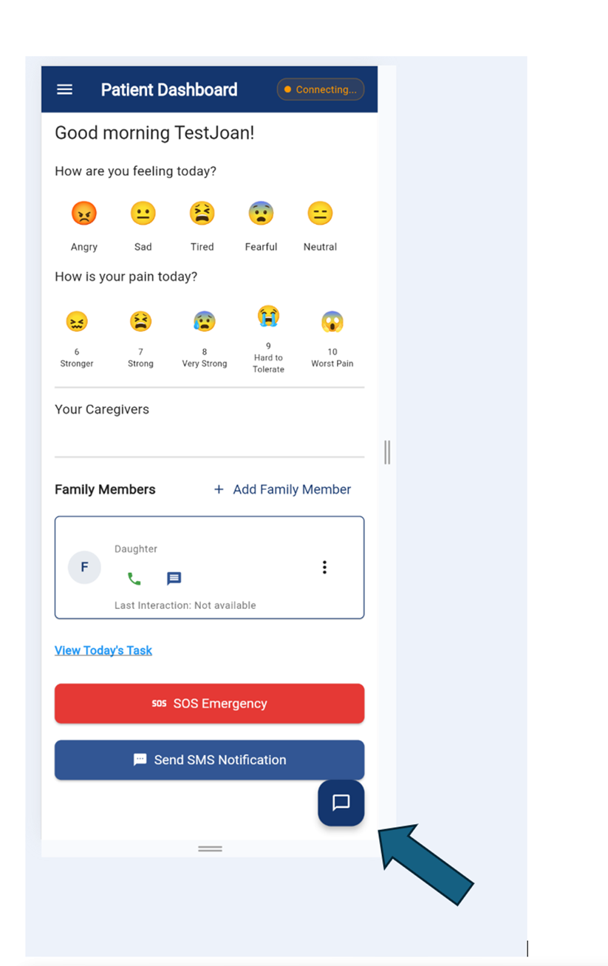

1. The Health Assistant window will open, providing a space where you can interact with the AI.
2. At the bottom of the window, you will see a square text input box. You can:

Type your question into the box or upload a document for review or question.

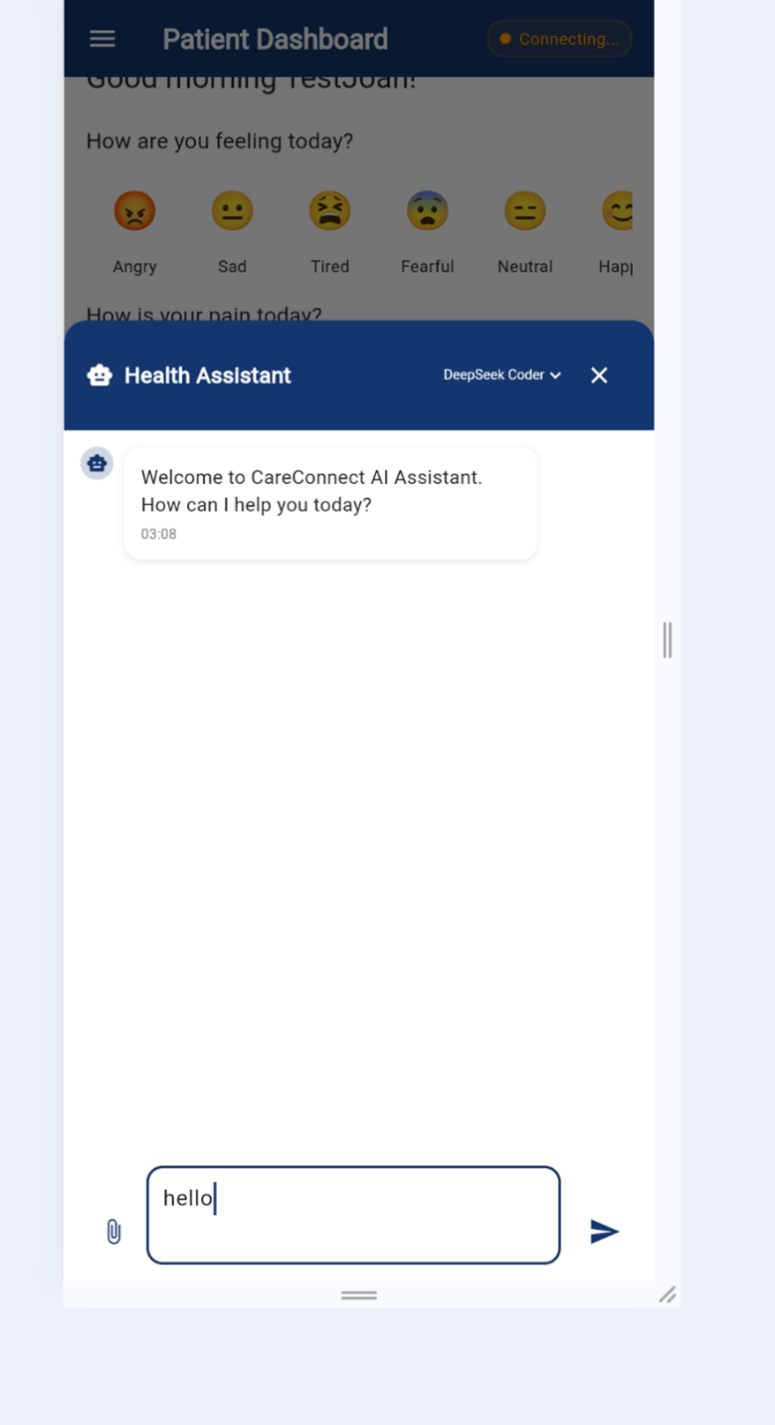

1. Once you have entered your question or uploaded your document, click the blue arrow to send your message or document.
2. Wait for the assistant to generate an answer based on context and logs.

## 4.8 Communication & Media

### 4.8.1 In-App Messaging (Text)

1. Tap the 'Messages' icon on the patient menu card.

Caregiver Dashboard

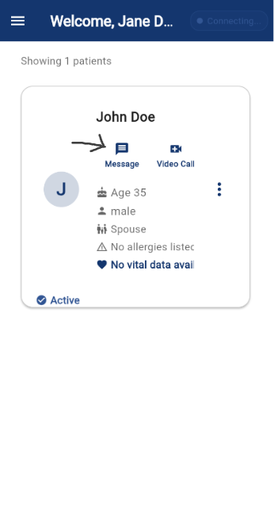

Patient Dashboard

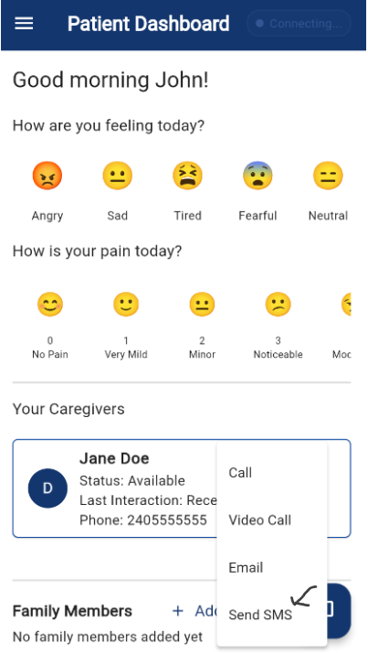

3. Type and send your message.

Caregiver Dashboard

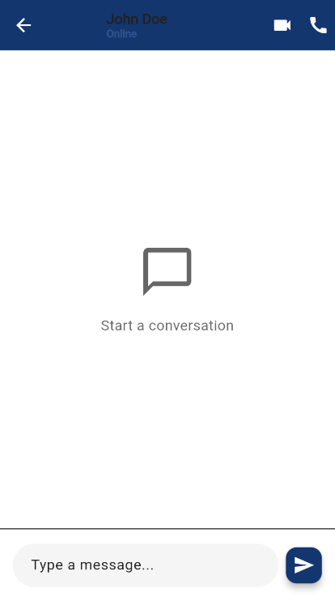

Patient Dashboard

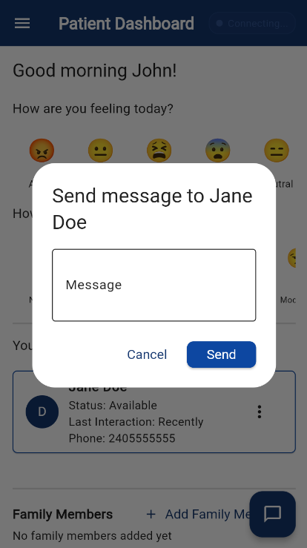

### 4.8.2 Voice & Video Calling

1. From a user profile or message thread, tap the 'Call' icon.

Caregiver Dashboard

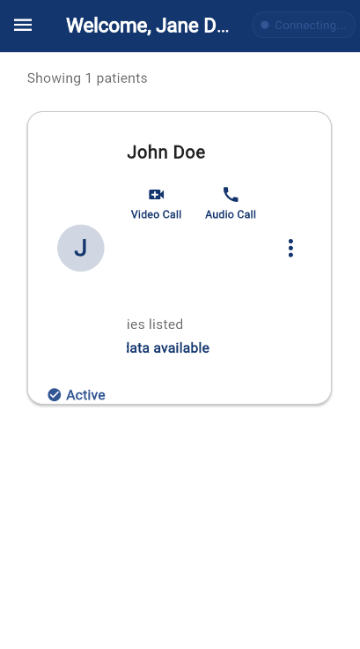

Patient Dashboard

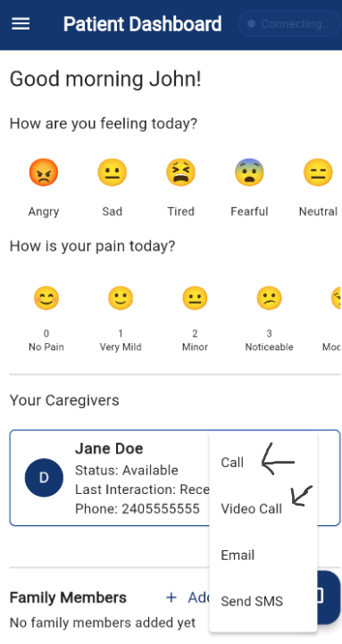

2. Choose between voice or video call.

Caregiver Dashboard



Patient Dashboard



3. Direct user to call screen.

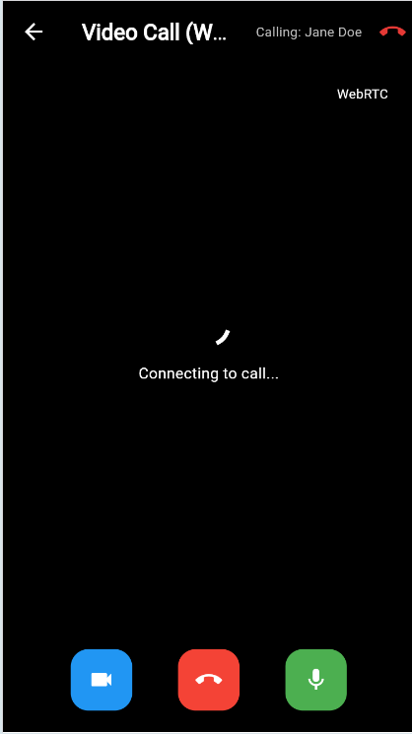

### 4.8.3 Emergency SOS Mode

1. Press and hold the 'SOS' button on the main screen.

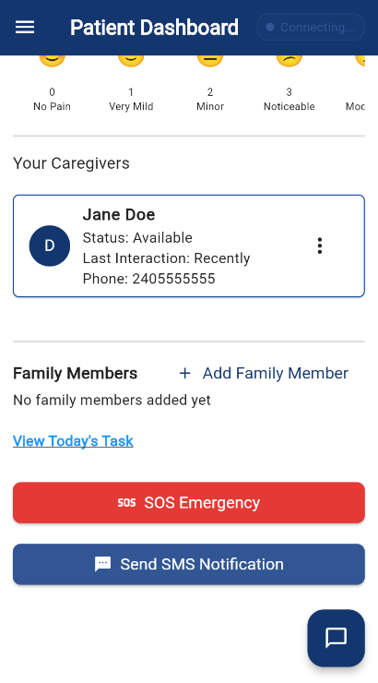

2. Select emergency type and confirm to send SOS message.

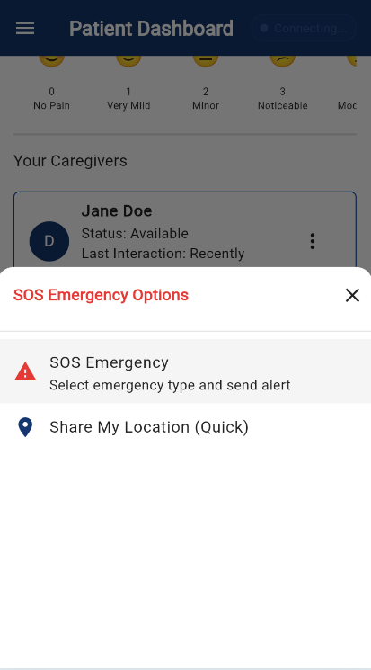

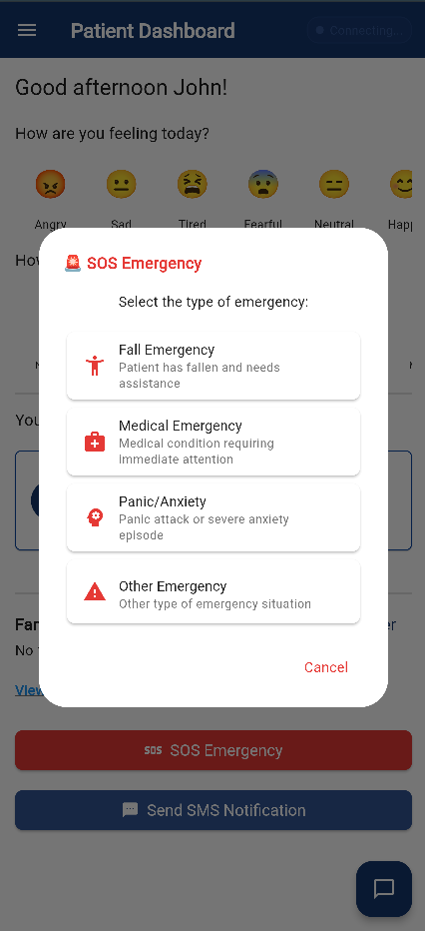

3. Tap 'Allow' to send the location and SOS alert to caregiver.

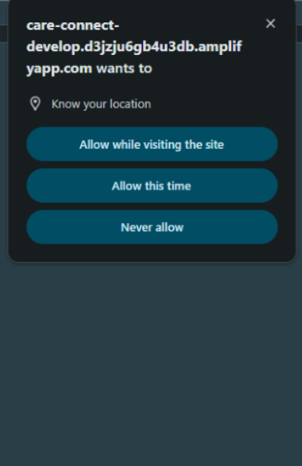

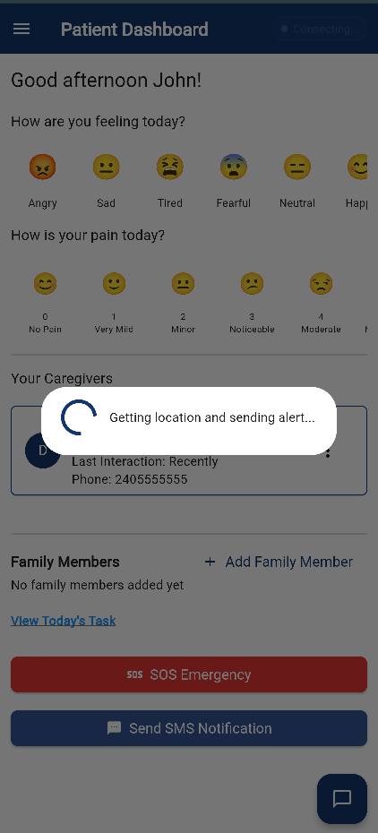

### 4.8.5 Media Uploads (Photos, Documents, Scans)

1. Navigate to 'Files Management' in the navigation menu of the dashboard.

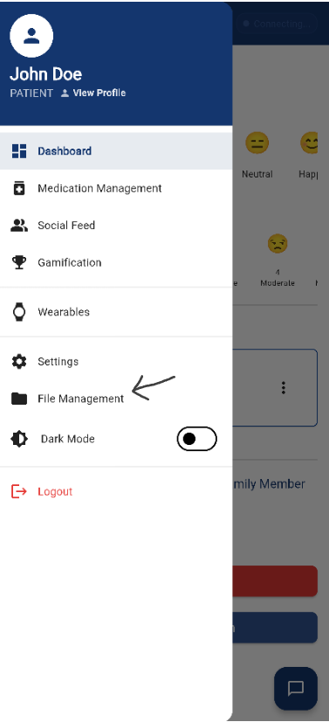

2. Select a ‘category,’ choose a file to add, and tap 'Upload' to upload the file.

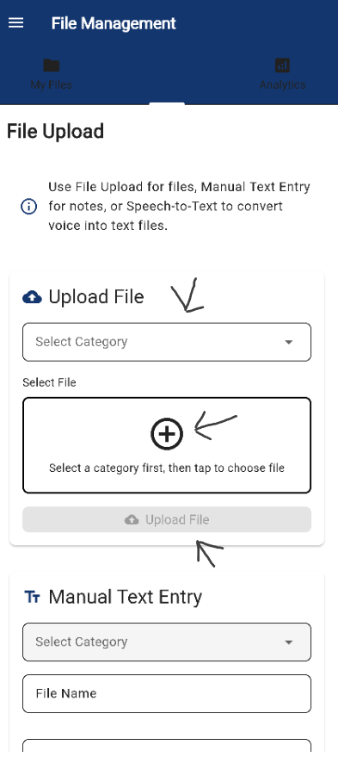

3. Select the file and confirm upload.

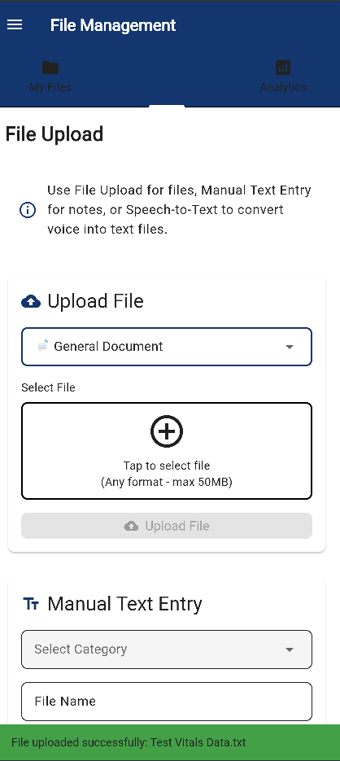

4. For manual text entry, enter the text of the file.

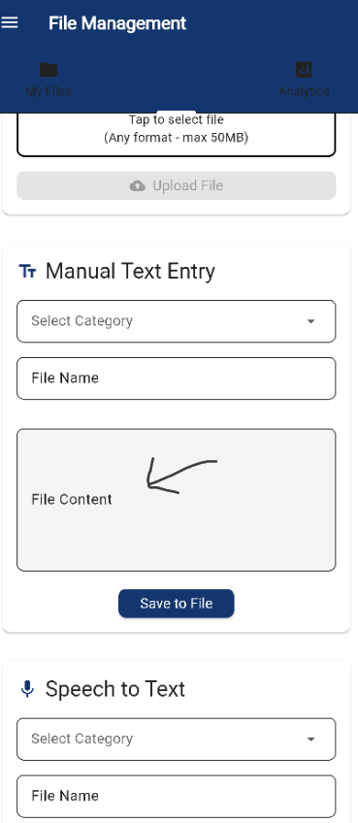

5. For speech-to-text, select the ‘Start Listening’ button, talk to add speech, and select ‘Stop Listening’ to stop speech-to-text.

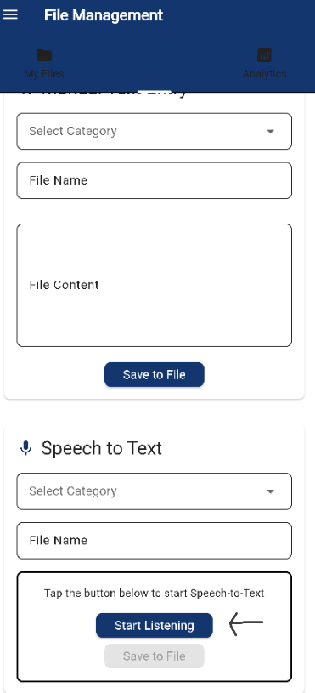

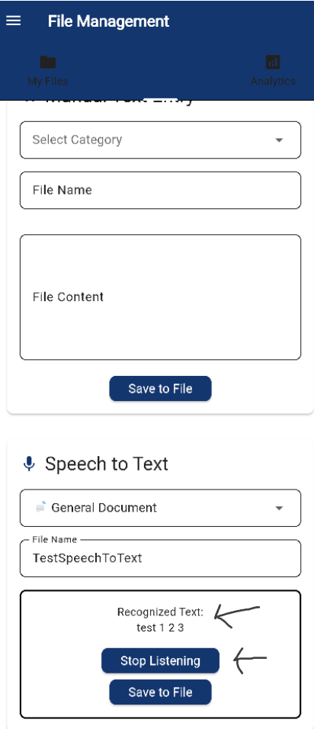

## 4.9 Device & Third-Party Integrations

### 4.9.1 Wearables

1. Go to the drawer and select 'Wearables'.

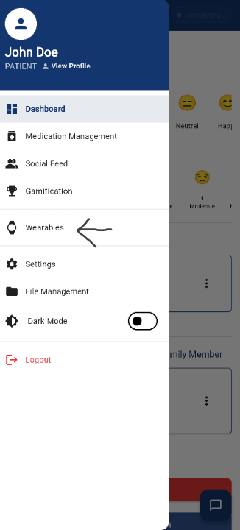

2. Connect compatible device (e.g., Fitbit, Apple Watch).

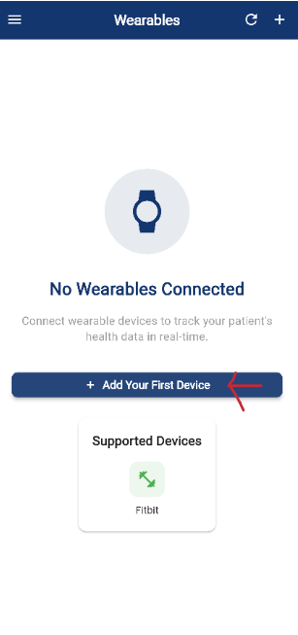

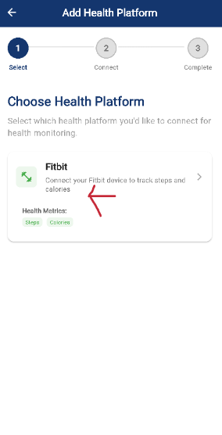

3. Grant permission to sync health data.

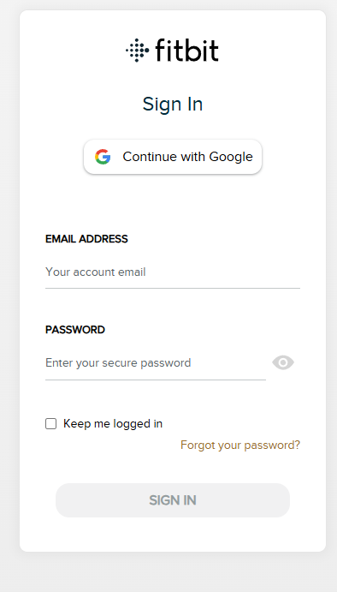

4. Health metric available on the metrics dashboard

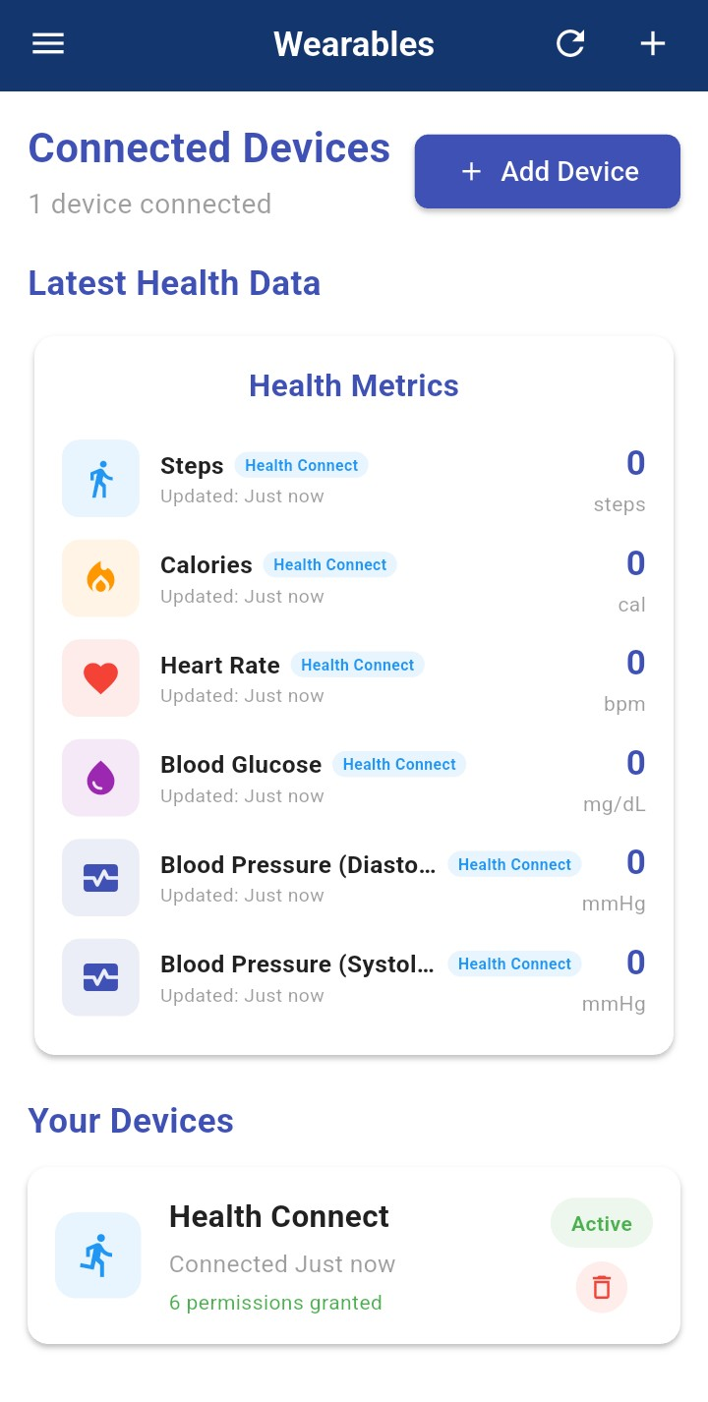

### 4.9.3 Medication Management

1. Open the 'Medication Management' tab in the drawer of the patient dashboard.

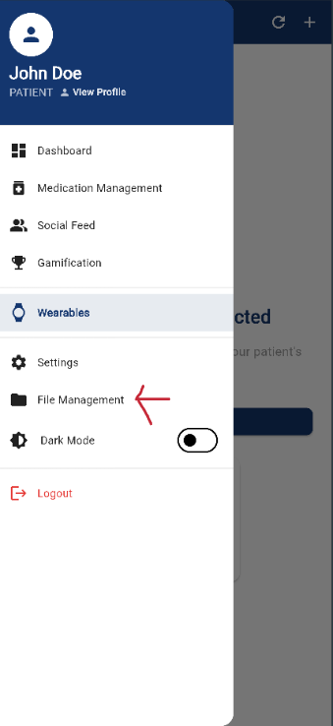

2. Select method of adding medication.

For pill bottle scan, select the ‘Scan Medication Barcode’ button

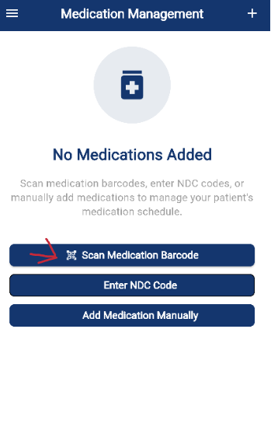

For manual add of NDC code, select the 'Enter NDC Code’

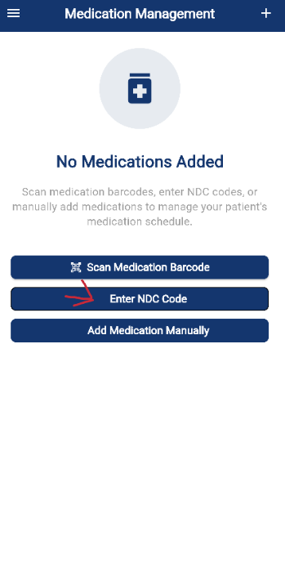

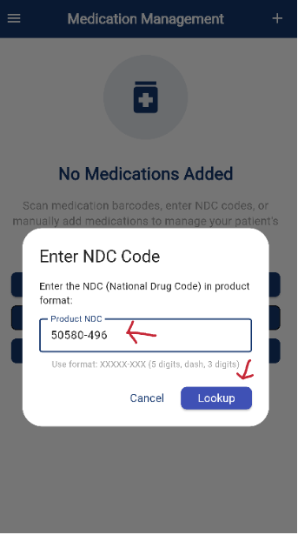

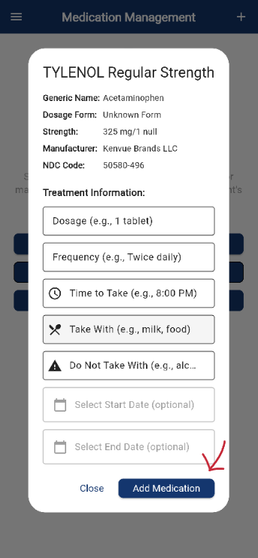

For full manual add, select the ‘Add Medication Manually’

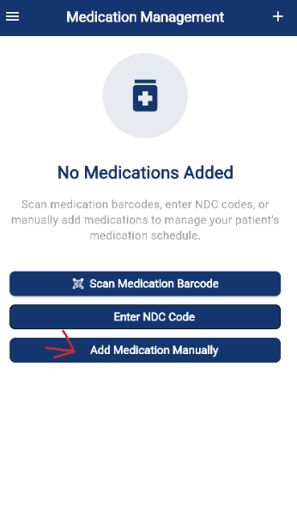

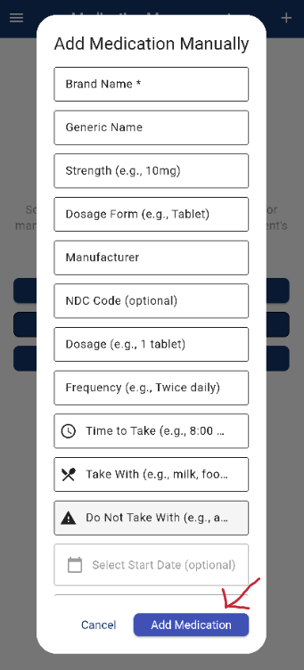

3.Add medication and view on the medication management page

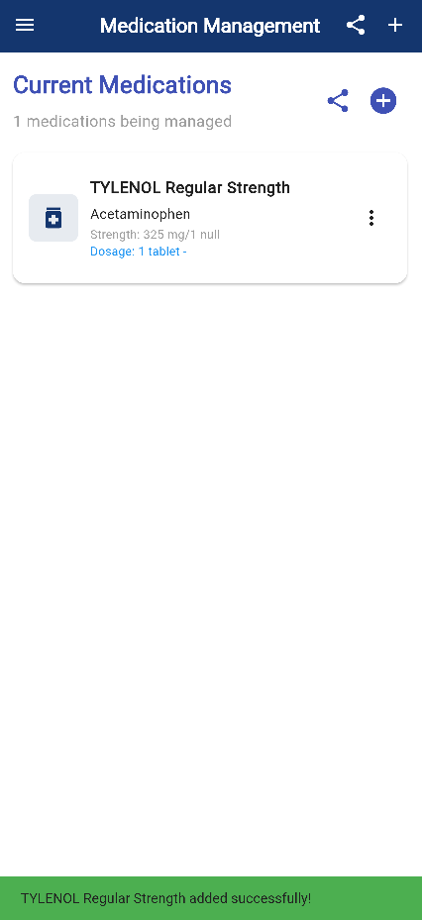

4. Share medication list by selecting the “Share” button in the top right. The system displays the options to share.

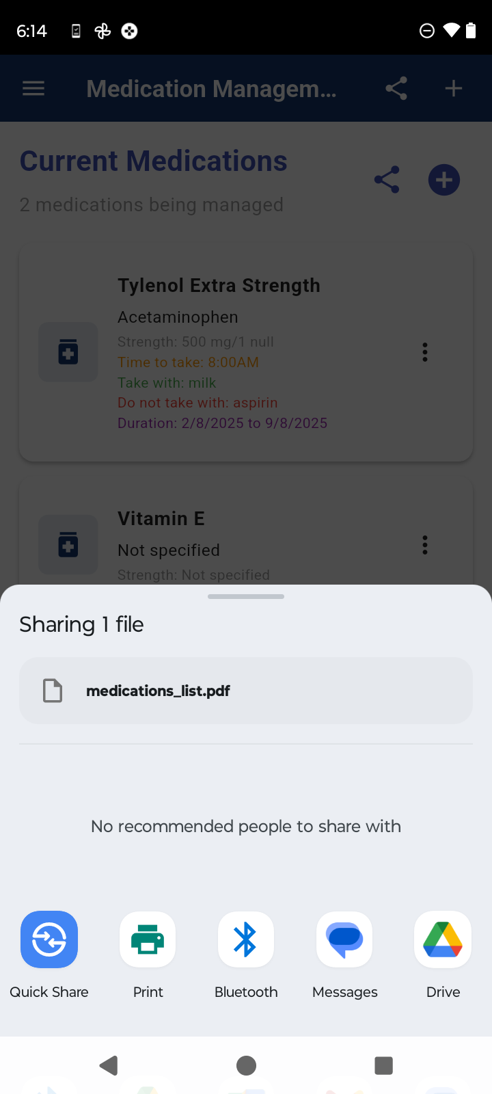

5. A pdf with the medication list and details is genearated by the system.

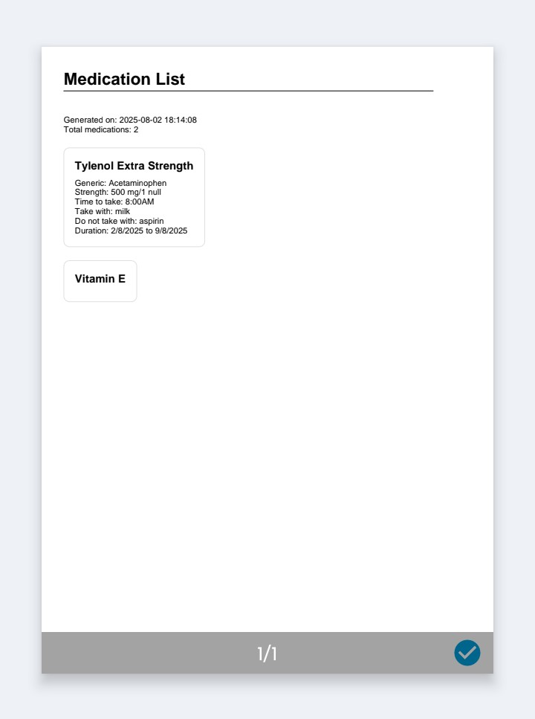

## 4.10 Gamification & Engagement

### 4.10.1 Provide Rewards for Completed Tasks

1.Gamification after completing a task (XP/Level progress showing)

After completing a task, you’ll see your XP increase and achievements update in real time.

2. View rewards progress on the Gamification main page under 'Achievements'.

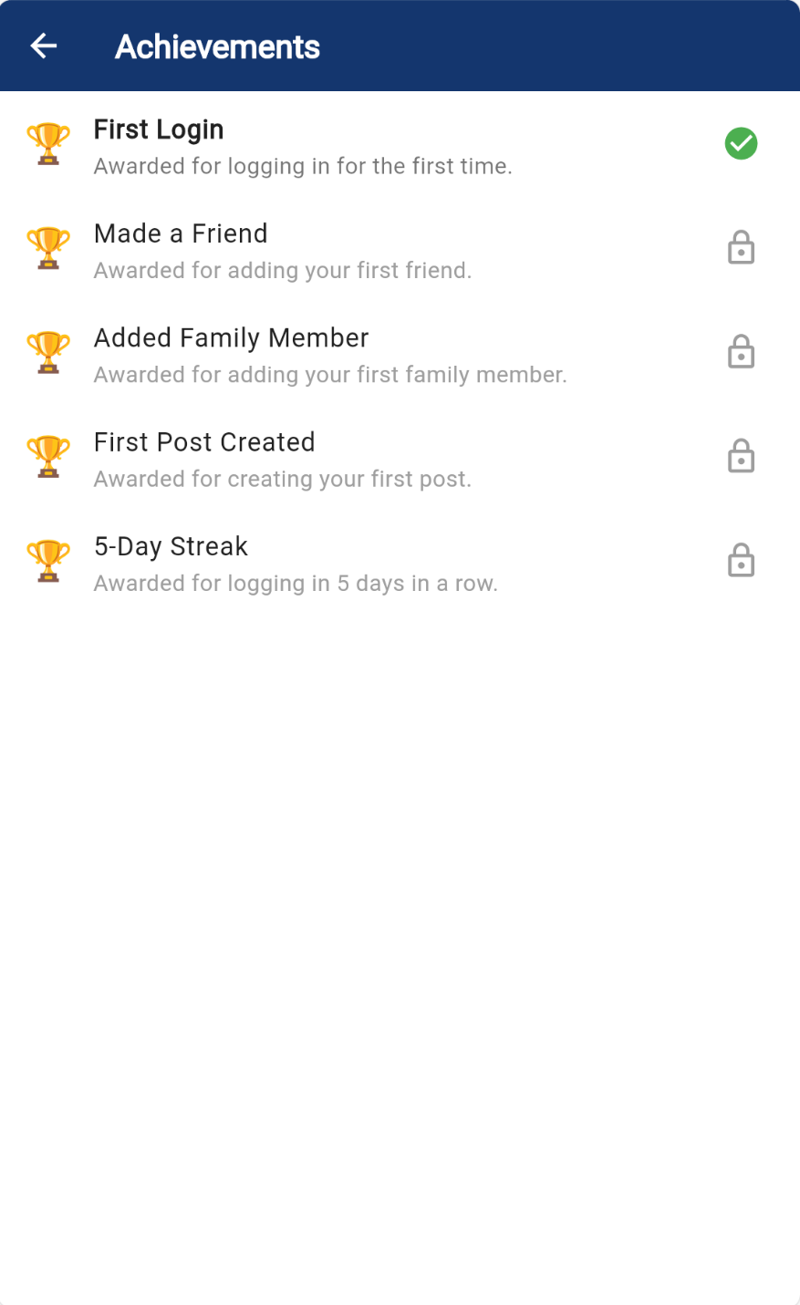

View your badges and progress anytime by visiting the Achievements section on your dashboard.

### 4.10.2 Daily Motivation Messages on Dashboard

1. Login daily to see a motivational message on your Gamification mainpage.

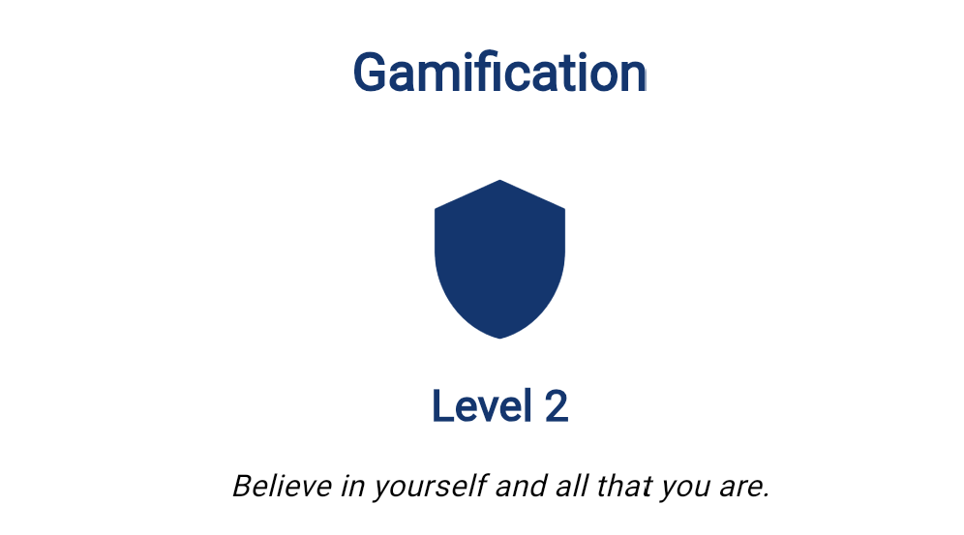

Gamification main screen showing the motivational message tile

### 4.10.3 Leaderboard Opt-in

1. Leaderboard screen showing streaks and comparison bars.

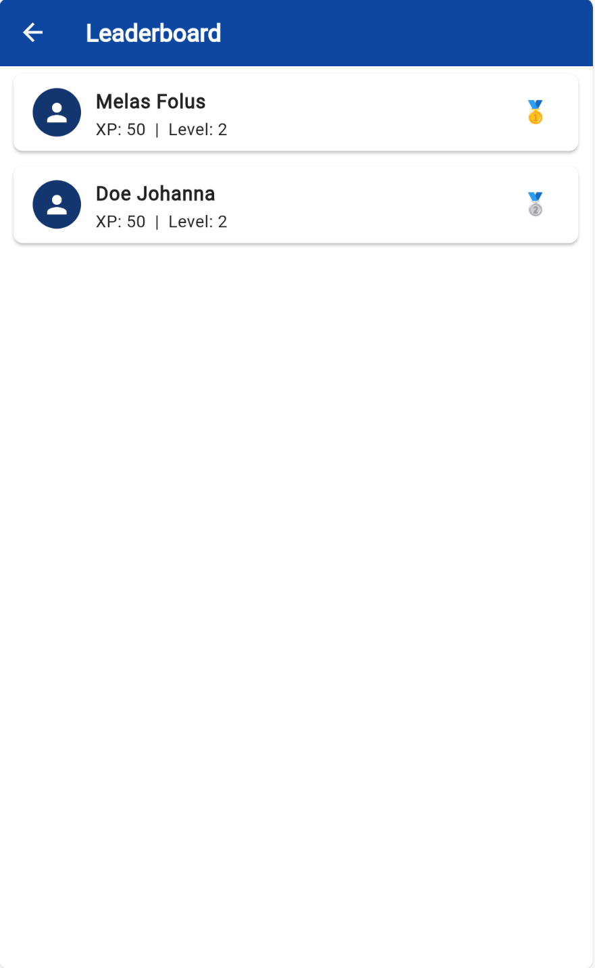

See how your XP/level compares to others

### 4.10.4 Social Networking (Connect with Other Users)

1. Navigate to 'Community' tab.

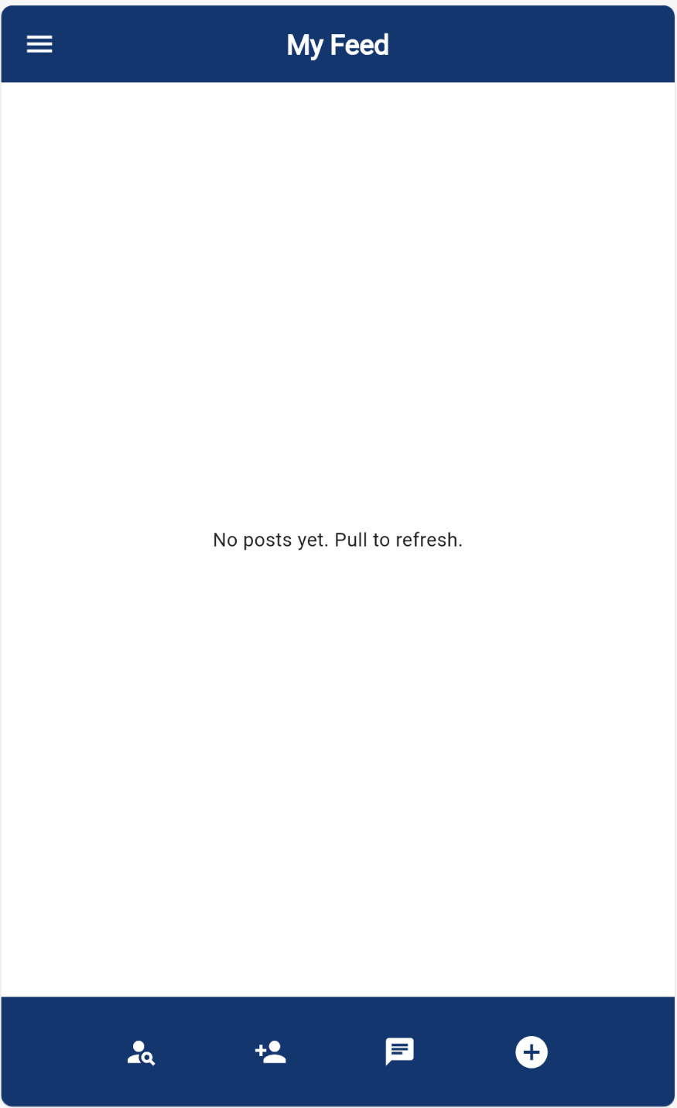

Navigate to the main social network page to see friend’s post

2. Send a connection request to approved users.

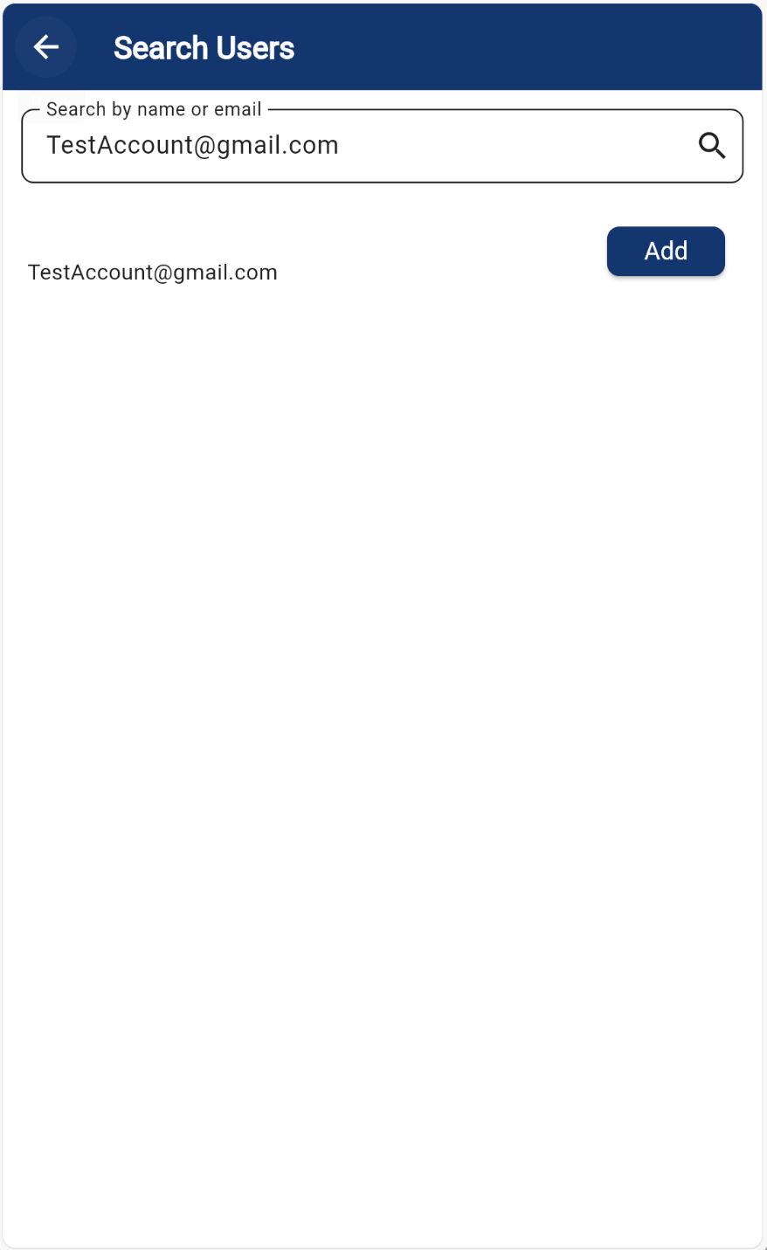

Search for friends and send a friend request

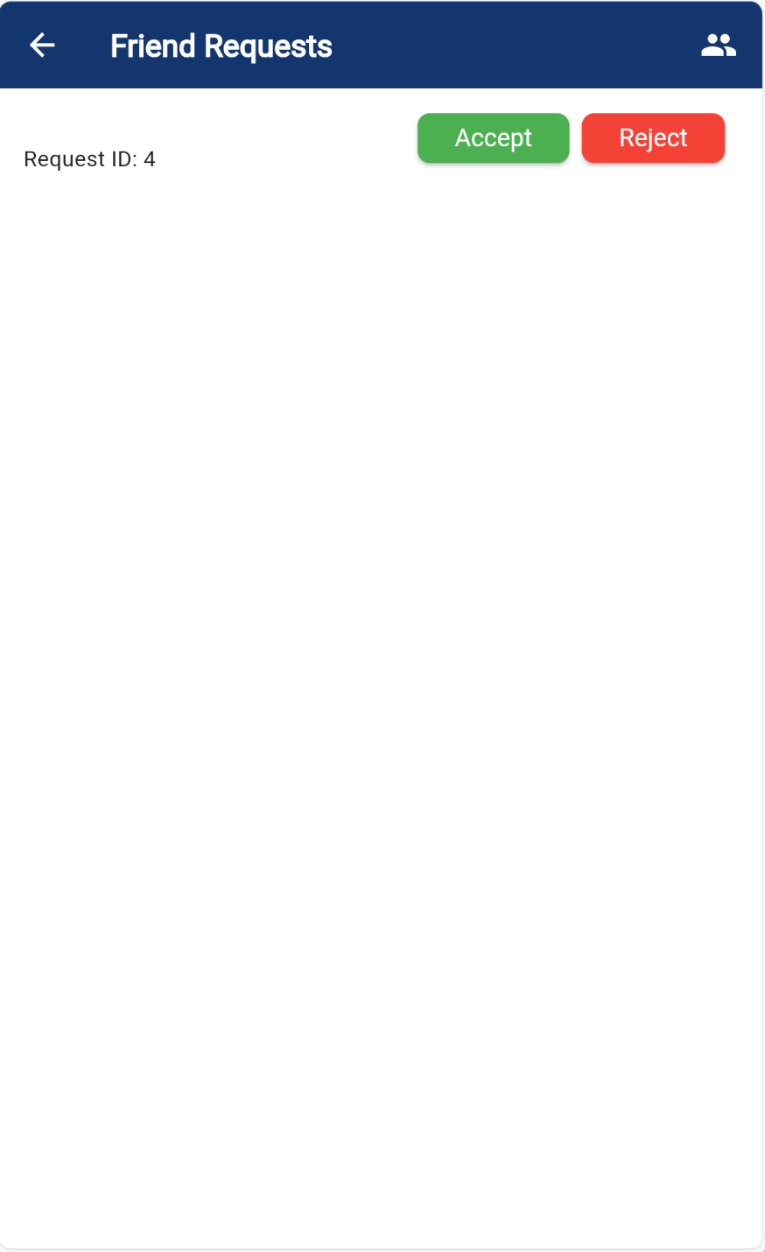

Accept or reject the friend request

3. Connect with others using the chat feature

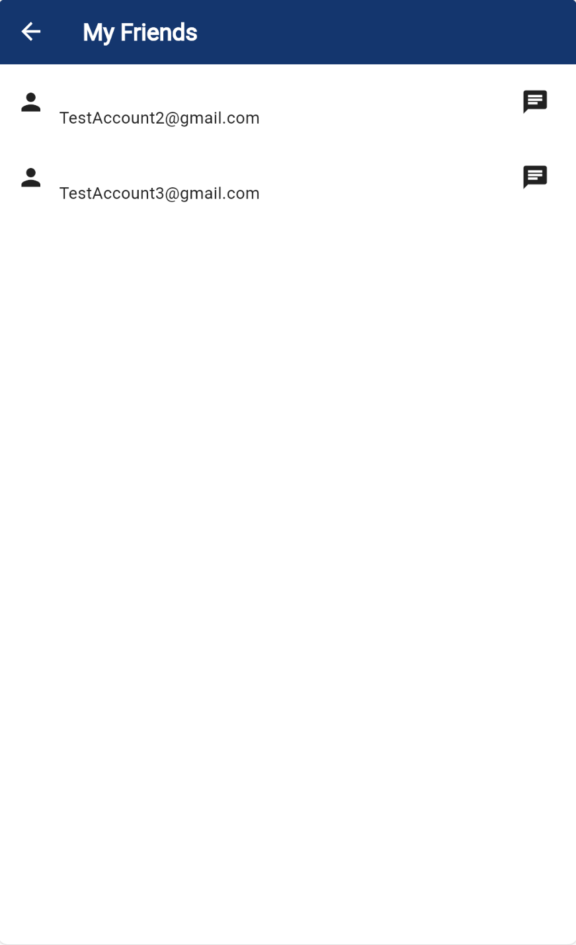

My friends page displays all the current friends

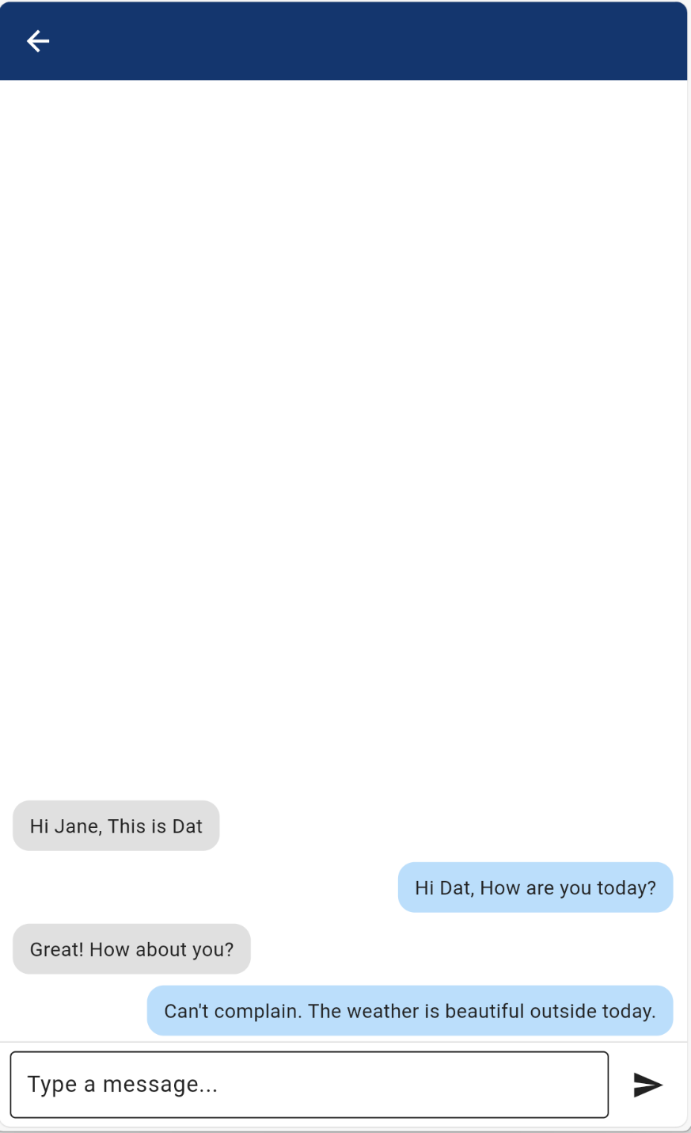

Click on message icon to send message to friends

## 4.11 Analytics & Reporting

### 4.11.1 Dashboard Metrics (Adherence Rates, Vital Trends)

1. Open Analytics from the caregiver or patient dashboard.

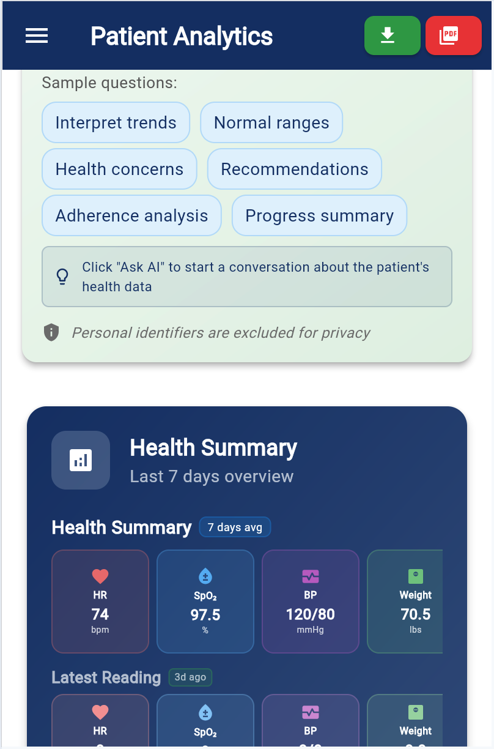

2. View graphs showing medication adherence, mood trends, and activity logs.

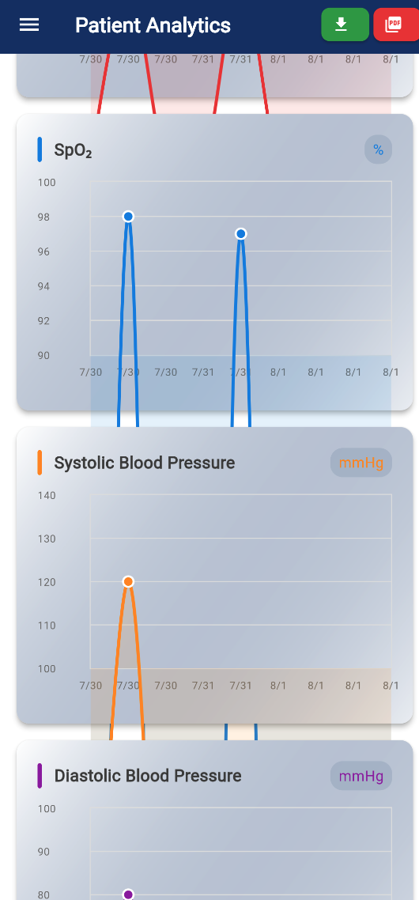

### 4.11.2 Report Exports (CSV, PDF)

1. Select desired report type and format (CSV or PDF).

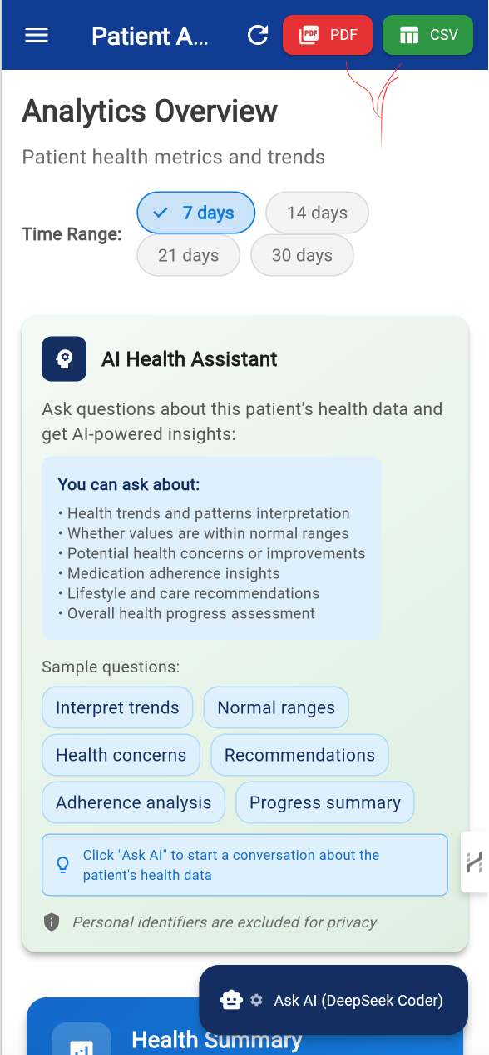

2. Click on the Selected button'.

### 4.11.3 Real-Time vs. Batch Processing

1. Enable real-time updates under 'Settings' > 'Data Preferences'.

2. For historical data, select batch processing from 'Reports' > 'Data Archive'.

# 5. Security, Data Management and General Settings

## 5.1 AI Configuration

1. Go to the settings from the hamburger menu.

2. Scroll down and Click “AI Configuration”

3. Choose your AI provider or scroll down to adjust the settings to your preferences.

4. When you are done Click “Save” to update the AI Configuration. You abort the process as well by clicking “Cancel”.

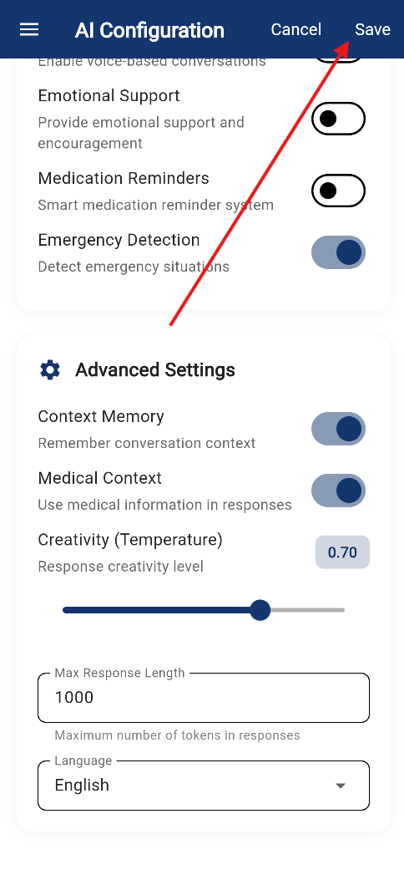

## 5.2 Clear Cache

1. Go to the settings from the hamburger menu.

2. Scroll down and Click “Clear Cache” in the General section.

3. Confirm the prompt by clicking “Clear Cache” or abort with “Cancel”

## 5.3 Switch to Dark Mode and Light Mode

1. Go to the hamburger menu on the top left icon when it is available

2. Click the toggle button to switch to Dark Mode or Light Mode depending on what your initial mode was.

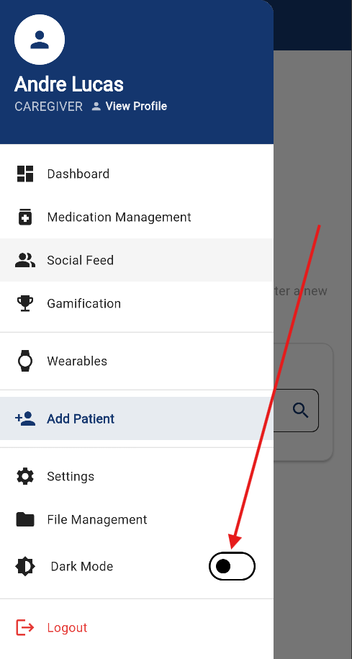

# 6. Troubleshooting

## 6.1 Common Issues and Solutions

1. Problem: Can't login → Solution: Tap 'Forgot Password' and reset.

2. Problem: No notifications → Solution: Check app and device notification settings.

3. Problem: SOS not triggering → Solution: Ensure GPS and permissions are enabled.

## 6.2 Contact Support

1. Go to 'Settings' > 'Help Center'.

2. Choose 'Contact Support' and describe your issue.

3. Expect a reply within 24 hours via email or chat.